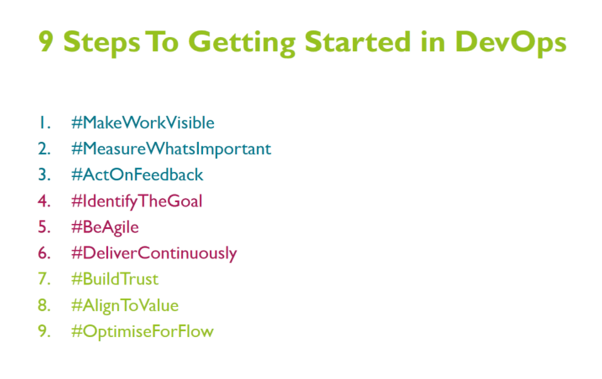

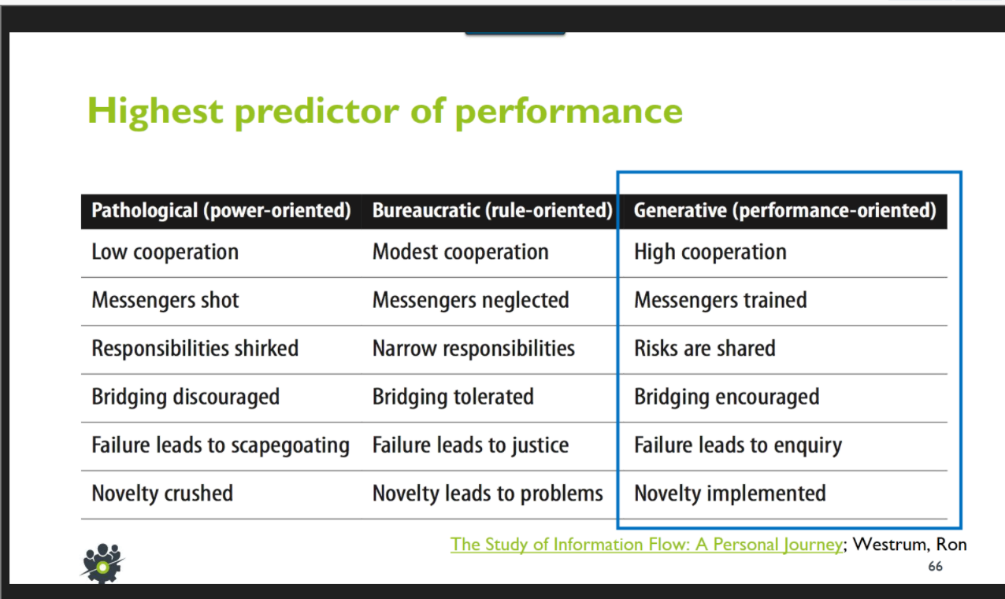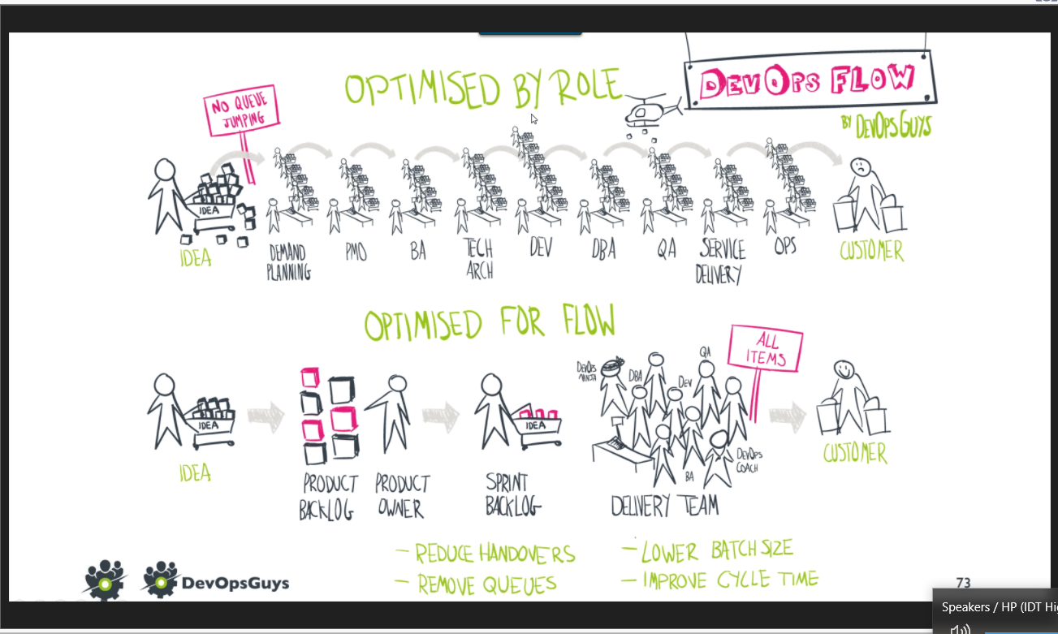Docker daemon or Docker engine

Only 1 host os…No Guest OS

Docker will create image. Image –OS file identifier/ template for environment.

We can create many container from image.

* In VMware, for each VM we need one OS
* Cost very low

Pull-> Download

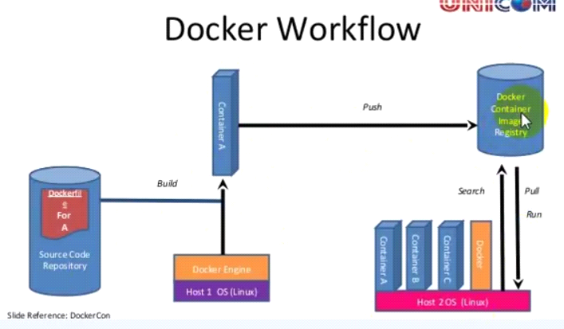

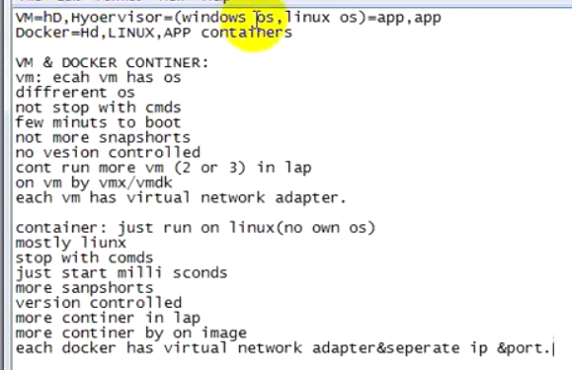  
**Learn Docker in 12 Minutes 🐳**

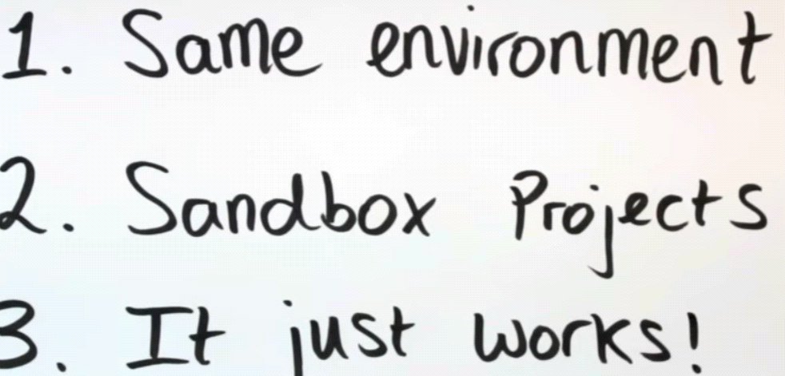

Docker uses host machine kernel.

All linux distributions centos,Ubuntu..built on same kernel

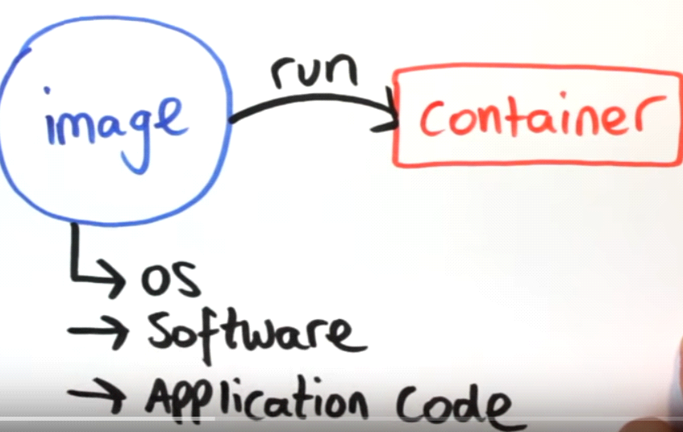

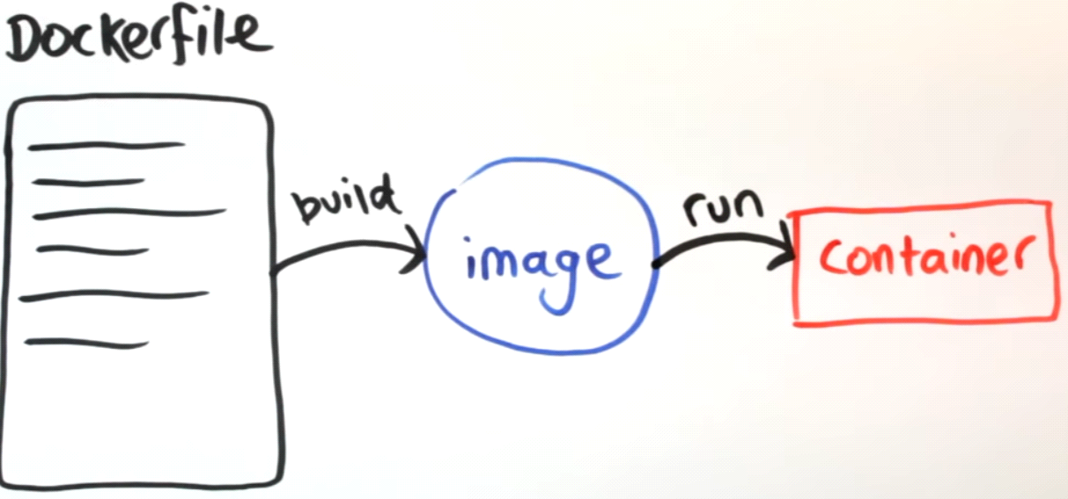

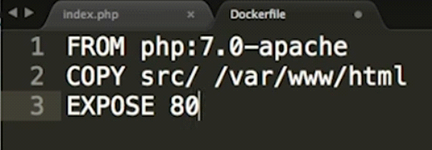

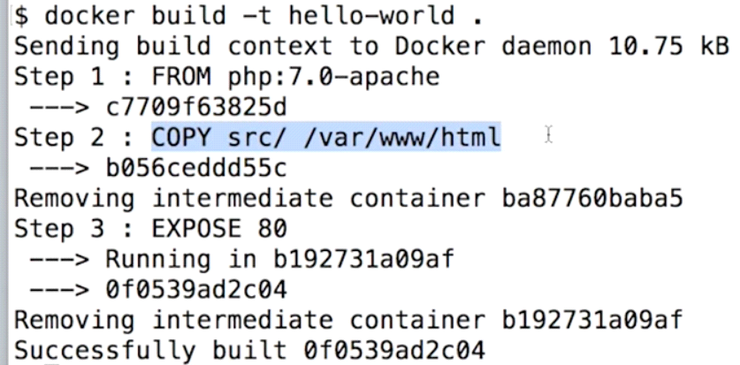

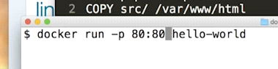

We need to build again..If we change content.

Sol: Share folder



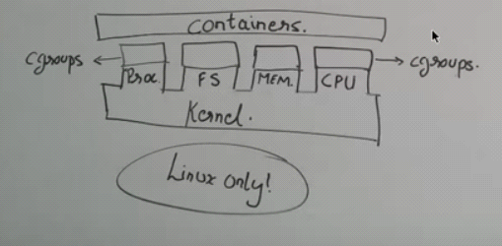

Cgroup: containergroup

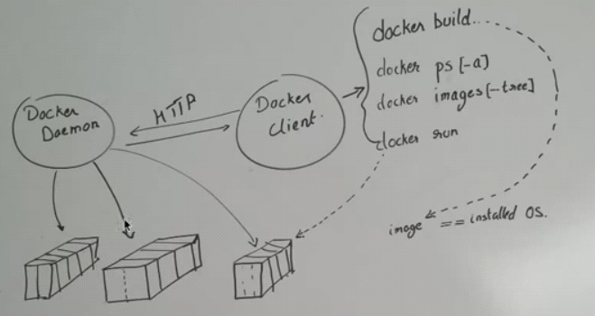

Create Custom image

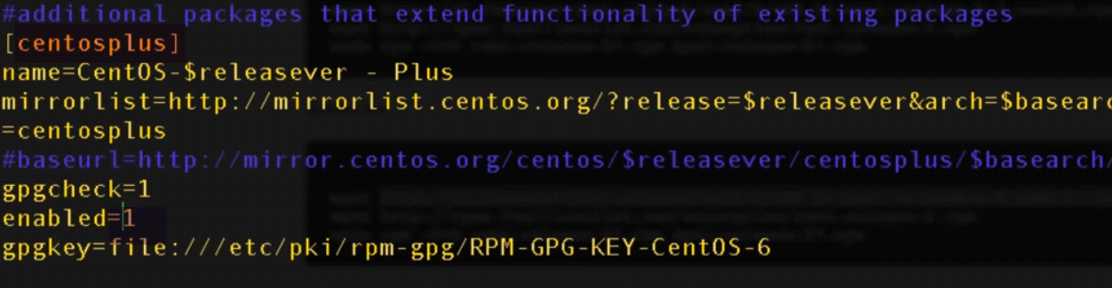

Add EPEL repo

Enabled=1 in centosplus-> CentOSBase.repo

Service docker start

Docker ps

Docker images

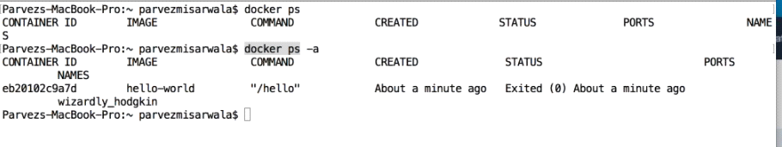

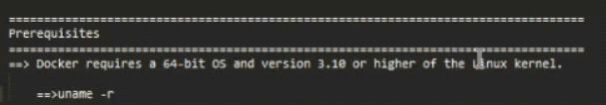

 Verify Requirements

For standard installation Docker required 64 bit operating system having Kernel >= 3.10 version. Older versions of Kernel have some missing requirements to run all features of Docker.

# uname -r

3.19.0-49-generic

|  |
| --- |
| * sudo yum update   sudo vim /etc/yum.repos.d/docker.repo  [dockerrepo]  name=Docker Repository  baseurl=https://yum.dockerproject.org/repo/main/centos/$releasever/  enabled=1  gpgcheck=1  gpgkey=https://yum.dockerproject.org/gpg  sudo yum install docker-engine  sudo systemctl enable docker.service  sudo systemctl start docker.service  sudo docker run hello-world  <https://tecadmin.net/install-and-manage-docker-on-centos/>    2.)  sudo yum update  curl -fsSL <https://get.docker.com/> | sh  systemctl enable docker.service  systemctl start docker.service  sudo docker run hello-world |

CentOS-6

Add the EPEL Repository

Docker is part of Extra Packages for Enterprise Linux (EPEL), which is a community repository of non-standard packages for the RHEL distribution. First, we’ll install the EPEL repository:

rpm -iUvh <http://dl.fedoraproject.org/pub/epel/6/x86_64/epel-release-6-8.noarch.rpm>

yum update -y

install Docker by installing the docker-io package:

yum -y install docker-io

service docker start

chkconfig docker on

sudo docker run hello-world

sudo docker images

|  |
| --- |
| Run docker without sudo   * Add the docker group if it doesn't already exist: * sudo groupadd docker * Add the connected user "${USER}" to the docker group. Change the user name to match your preferred user: * sudo gpasswd -a ${USER} docker * Restart the Docker daemon: * sudo service docker restart * If you are on Ubuntu 14.04-15.10* use docker.io instead:   sudo service docker.io restart |

|  |
| --- |
| **Allow a User to Run Only Specific Commands**  While you can blacklist specific commands and prevent users from running them with sudo, this isn’t very effective. For example, you could specify that a user account not be able to run the shutdown command with sudo. But that user account could run the cp command with sudo, create a copy of the shutdown command, and shut down the system using the copy.  A more effective way is to whitelist specific commands. For example, you could give a Standard user account permission to use the apt-get and shutdown commands, but no more. To do so, add the following line, where standarduser is the user’s username:  standarduser ALL=/usr/bin/apt-get,/sbin/shutdown  image  The following command will tell us what commands the user can run with sudo:  sudo -U standarduser –l  image |

Issues:

After installation:

1.)udo /etc/init.d/docker status

docker dead but pid file exists

**Sol:** yum update -y device-mapper-libs

<http://stackoverflow.com/questions/27216473/docker-1-3-fails-to-start-on-rhel6-5>

2.) service docker status

**docker dead but subsys locked**

[root@localhost ~]# service docker status

docker dead but subsys locked

[root@localhost ~]# **service docker restart**

Stopping docker: [FAILED]

Starting docker: [ OK ]

[root@localhost ~]# service docker status

docker (pid 2241) is running...

3.) [skytap@host-1 ~]$ ls -l /var/run/docker*

-rw-r--r--. 1 root root 4 Apr 3 23:27 /var/run/docker.pid

srw-rw----. 1 root root 0 Apr 3 23:27 /var/run/docker.sock

[skytap@host-1 ~]$ cat /etc/group

dockerroot:x:982:

4.) [skytap@host-1 ~]$ docker run -it ubuntu /bin/bash

**/usr/bin/docker-current: Cannot connect to the Docker daemon. Is the docker daemon running on this host?.**

See '/usr/bin/docker-current run --help'.

[skytap@host-1 ~]$ service docker status

Redirecting to /bin/systemctl status docker.service

● docker.service - Docker Application Container Engine

Loaded: loaded (/usr/lib/systemd/system/docker.service; disabled; vendor preset: disabled)

Active: active (running) since Mon 2017-04-03 23:27:52 PDT; 1min 54s ago

[skytap@host-1 ~]$ sudo docker run -it ubuntu /bin/bash

Unable to find image 'ubuntu:latest' locally

Trying to pull repository docker.io/library/ubuntu ...

latest: Pulling from docker.io/library/Ubuntu

5.) [skytap@host-1 ~]$ sudo docker run -it ubuntu /bin/bash

Unable to find image 'ubuntu:latest' locally

Trying to pull repository docker.io/library/ubuntu ...

latest: Pulling from docker.io/library/ubuntu

d54efb8db41d: Pull complete

Digest: sha256:dd7808d8792c9841d0b460122f1acf0a2dd1f56404f8d1e56298048885e45535

panic: standard_init_linux.go:178: exec user process caused "permission denied" [recovered]

panic: standard_init_linux.go:178: exec user process caused "permission denied"

goroutine 1 [running, locked to thread]:

panic(0x6f3000, 0xc420118f50)

Disable Selinux /etc/selinux/config -🡪 disabled

6.)

[vobadm@devosp1 ~]$ sudo groupadd vboxusers

[vobadm@devosp1 ~]$ sudo usermod -a -G vboxusers vobadm

[vobadm@devosp1 ~]$ sudo mount -t vboxsf sf_C_DRIVE /home/vobadm/Desktop/shared_folder

/sbin/mount.vboxsf: mounting failed with the error: Protocol error

[vobadm@devosp1 ~]$ sudo mount -t vboxsf C_DRIVE /home/vobadm/Desktop/shared_folder

[vobadm@devosp1 ~]$

**Docker Deep Dive**

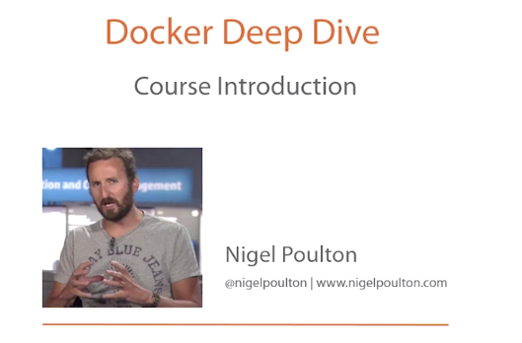

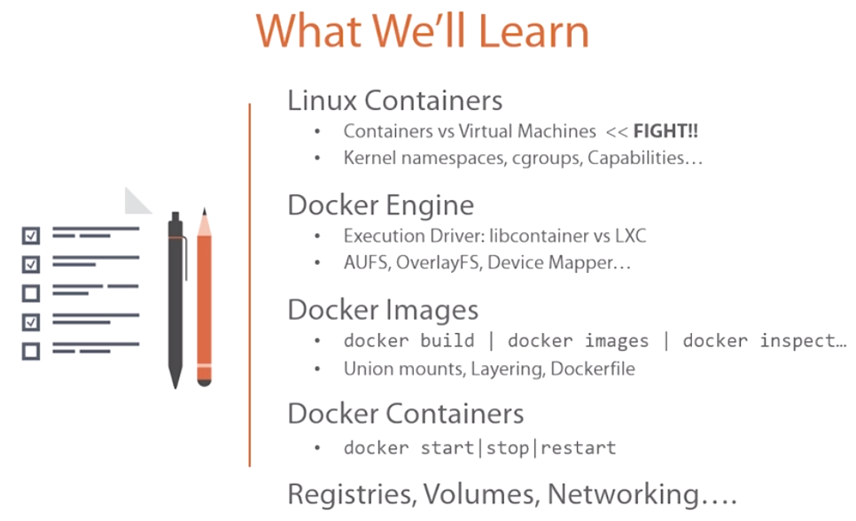

**I.1.)** 



1. **devops_-The Rise of the Virtual Machine**

**10 applications**🡪 **10 servers, 10 POs->10 OS-> 10 OS licenses-< 10 tools -> redundant coolers-> 10 networking cables, switchboards**

**10 weeks to setup.**

**PO-> make order->rack server->build os-> app install**

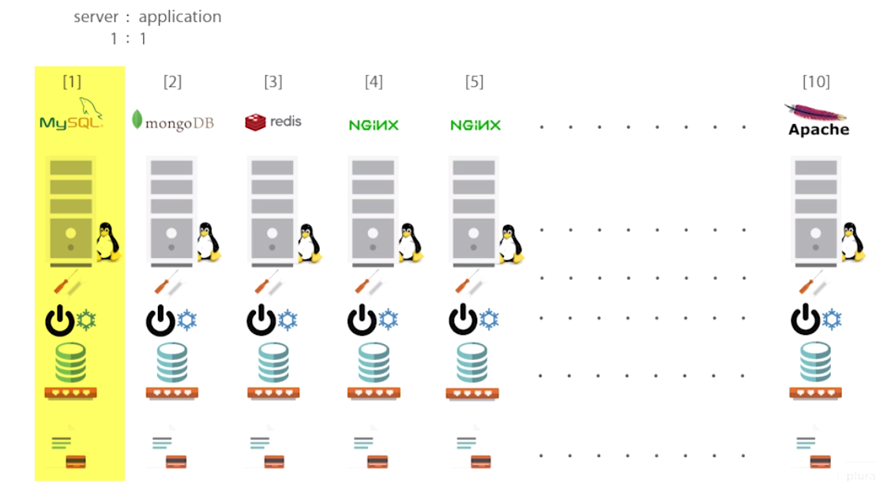

**Massive water of resources,…Actullay we use only 10% of resourses**

**Cost ton in CAPEX-APEX Cost**

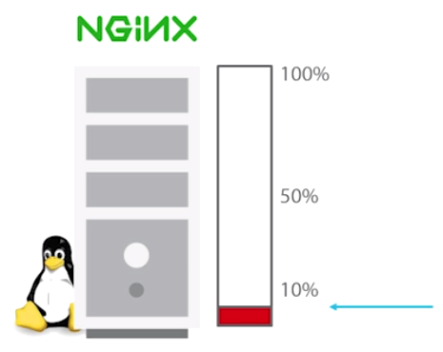

1. **Devops_02_02-The Ugly Virtual Machine Virtualization**

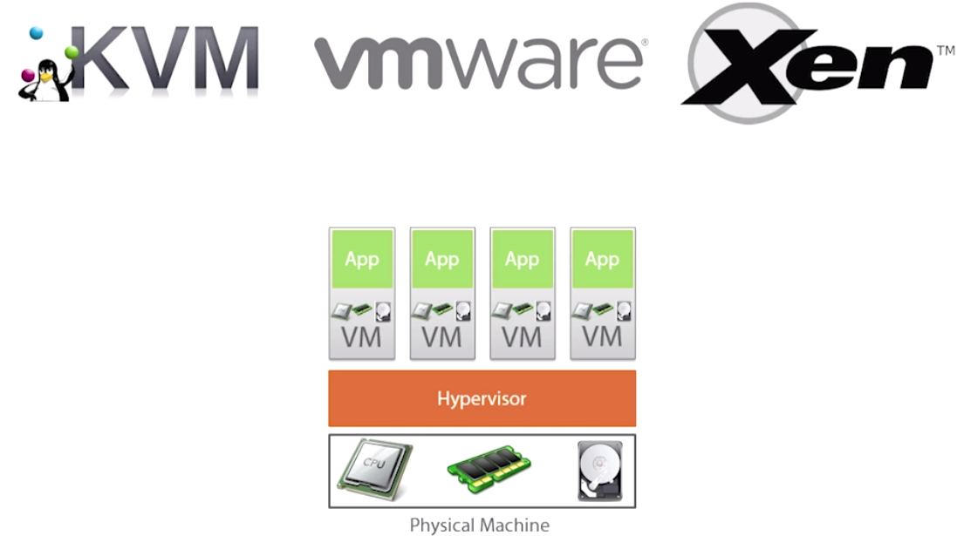

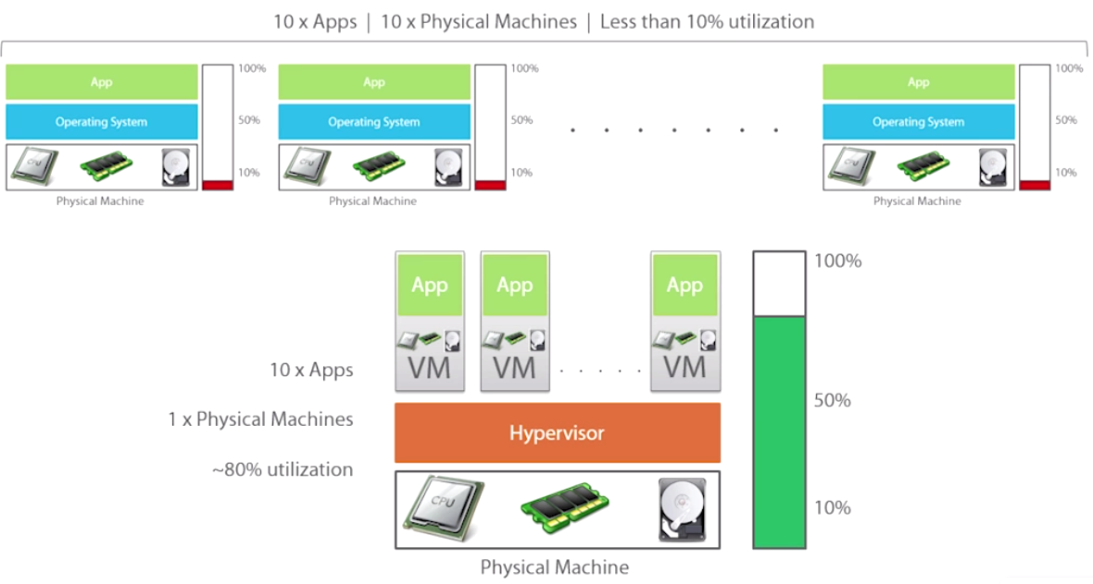

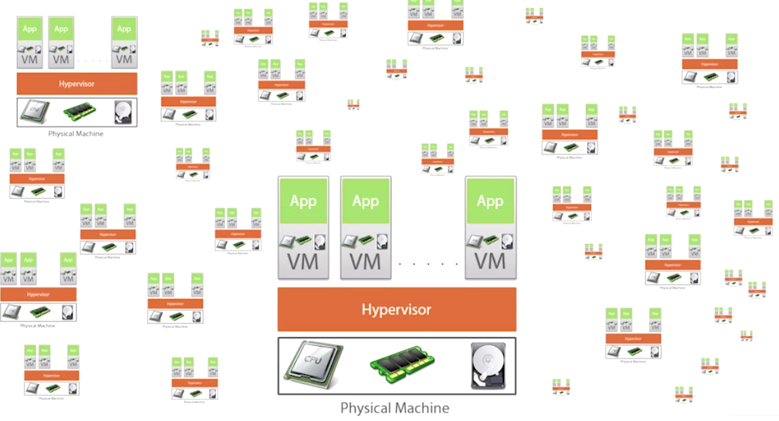

1. **OS only exists to facilitate application.**

**Spin up application without need of OS??**

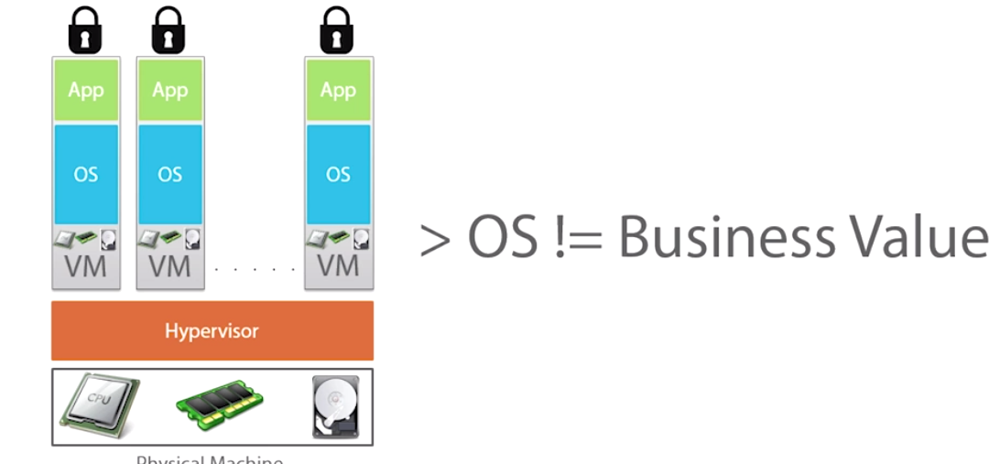

**We still need 10 Guest OS for 10 applications**

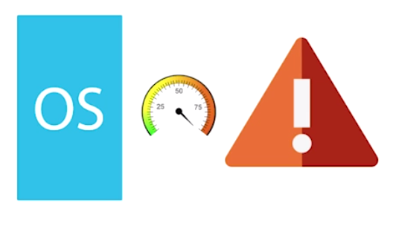

**Every OS has bunch of overheads🡪consumes RAM, HDD, CPU**

**Each OS has individual licensing**

**OS is waste of resources.**

**No matter how big company is… Think of only its applications..**

**- Secure, isolated, minimal OS services..**

**3.) Devops_ Containers**

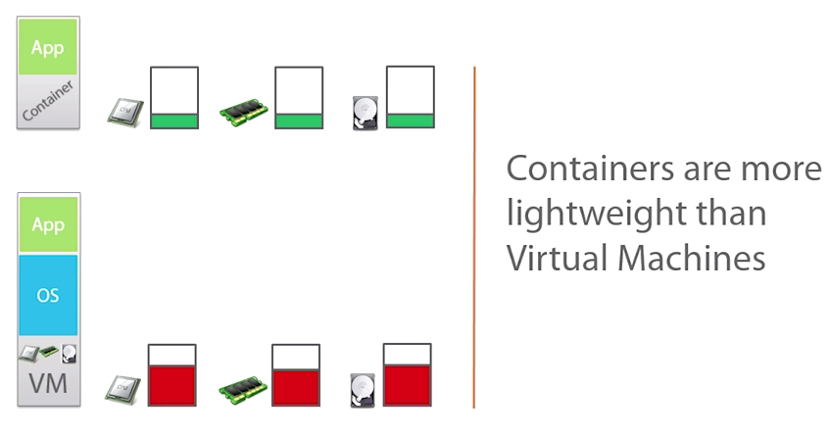

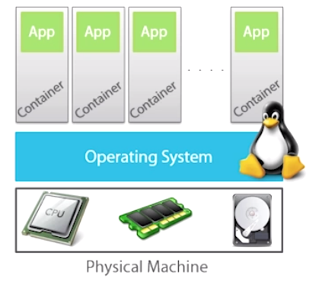

**OS installed on hardware/bare metal**

**Linux kernel owns and manages hardware below it.**

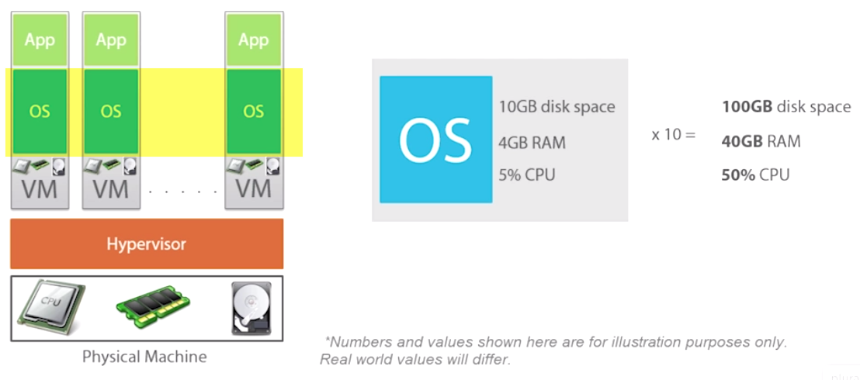

**10 windows licenses**

**Each Container here is a super-light weight OS. (NOTHING like full blown OS, as in VM).**

**Every container shares single common linux kernel, down in the host.**

**So single instance of kernal on machine.**

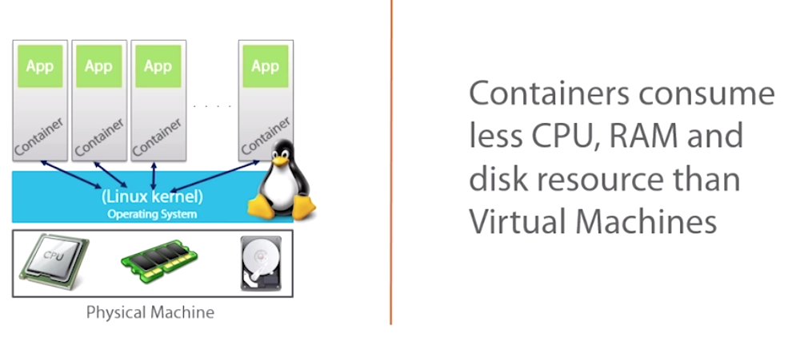

**Also –Portable**

**- faster**

**4) devops_ 02_04-Containers Under the Hood**

**Why can’t we install 5 apps in OS ??**

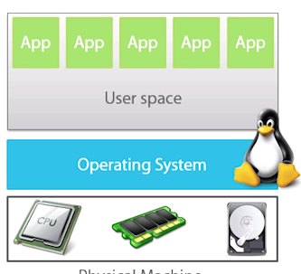

**Lets say 2 apps..Both share common library file. Each need different version of file on same system???**

**-Container is isolated instance of user Space**

**- A system with 10 containers have 10 isolated and independent user space….So we can safely install 10 apps on system.**

**We need isolated instances like root FS, process tress, networking stacks**

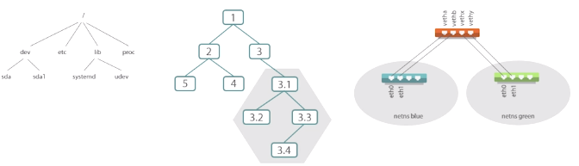

**EX: isolated view of root FS=> 1 container can have its own FS**

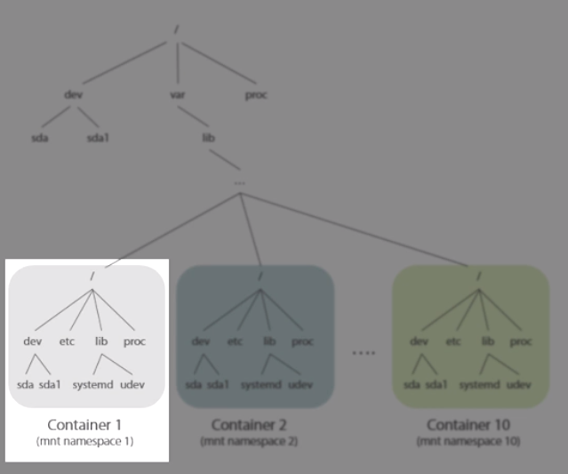

**10 containers=> 10 independent isolated views of root FS**

**An APP running in container-1 can add, modify, remove files(libraries or any) anywhere within its view of FS without impacting other container.**

**Clear: Each container have its view of root FS.So can mess around without impacting other containers**

**ii.) 10 containers->10 independent isolated process trees.**

**Process in 1 container cannot send signal to other. It’s isolated**

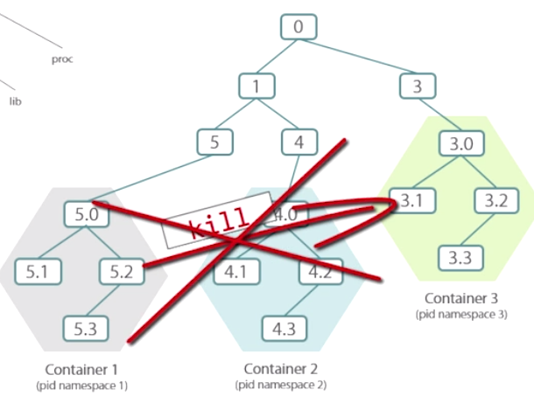

**iii.)** Each container get’s its own network stack. IP address, Port range,it’s own routing table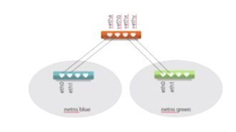

HOW??????????????

How we get this isolation??????????????????

This kind of isolation is achieved by feature called

1.)**Kernel namespaces.**

**2.) CGroups (Control groups)**

**It does- PId, networking, FS(mnt), user namespaces..**

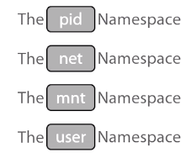

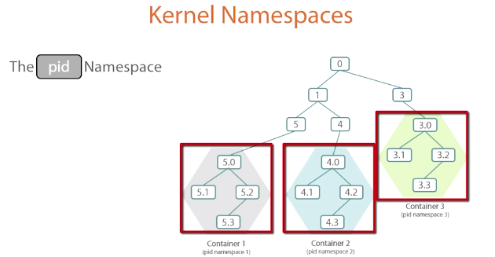

**Partition of namespace like pid/process tree🡪 Isolated partion to 1 container**

**-> Another isolated partition to other container**

**Fig: Single process tree from view of host.**

**Each of these Partitions here get assigned to specific container, and**

**Each of these containers are like WALLS.**

**ii.) cgroup(Control groups)**

**Recourses group together and apply limits.**

**In case of container, we map container to cgroups (1-1 mapping) and we set limits on CPU,RAM,…container have access to**

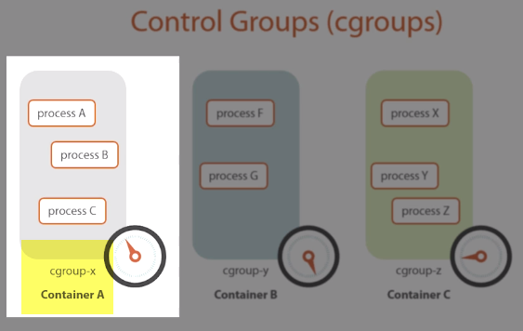

**Cgroups are really flexible..**

**Need to increase CPU,MEM (resourses)???...Simple. Just tweak cgroup limits**

**- more flexible than VCPU,VCPU on hypervisor**

**Specially -If we plan multiple container on system, like we do…especially when containers have hostile(**opposed or unfriendly)  **workloads, well we need container system that supports cgroups.**

**iii.) Capabilities**

* **What privileges user or process gets...**
* **Security**

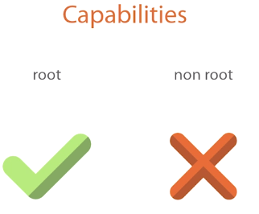

**Capabilities take privileges of root user and break them down into small privileges. Then we can assign those small privileges as and when required.**

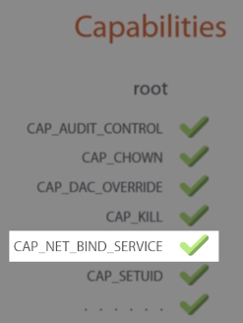

**EX: Suppose we have a process is able to bind socket to lower number port.. We need any of special privileges.**

**Instead of granting root, way from giving root privilges we can grant CAP_NET_BIND_SERVICE.**

**bind socket on privileged lower number port.**

**___> More secure**

**Docker**

**Docker is both a company…Technology/platform**

**Docker is container runtime.**

**Docker is actual implementation of container technology.**

**It brings together kernel namespace, cgroups, capabilities…All of those steps into product.**

**Docker container🡪ubuntu, redhat to kernal**

**It’s a package shipping implementation we can get support for.**

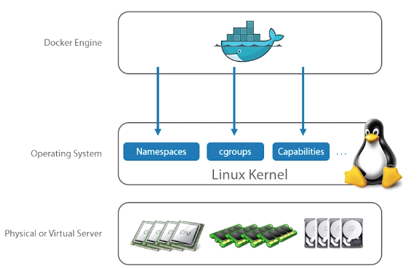

**Docker provides very uniform std run-time.**

**We need run-time for application to execute—devices,FS, privileges, variables,functions, API’s**

**std run-time-🡪 Developers can code apps literally in their laptops and literally lift them and drop into containers in AWS, Azure, data center.**

**Doesn’t matter where.. as long as Destination is running docker runtime/daemeon**

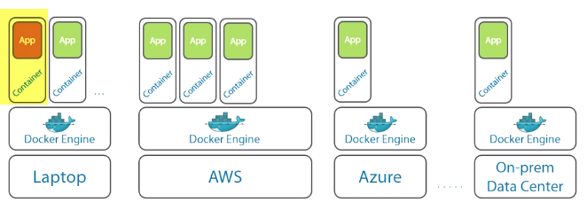

**Honestly how crazy it is..**

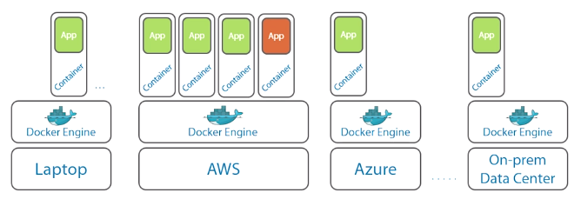

**It’s not like writing app for android. That app should work on any firm/or any tablet that run android.**

**This feature is wickedly cool for any application.**

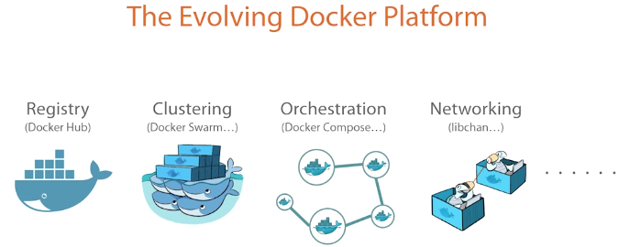

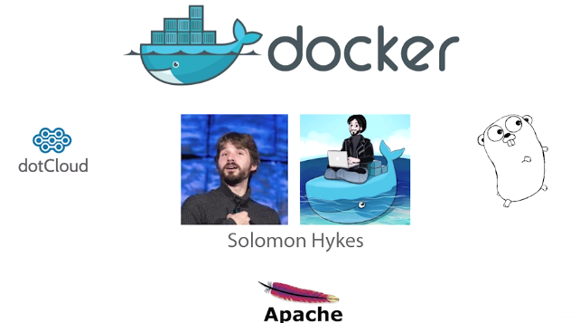

**Licenses under apache2 license.**

**Written in google Go language**

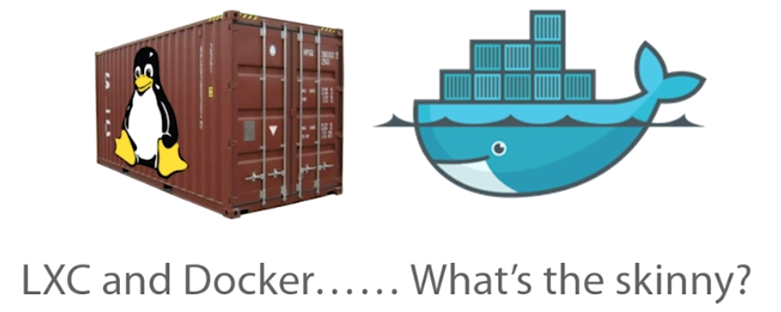

**Before-> Docker used LXC as default execution driver like an interface to kernel..**

**Namespace,capabilities..**

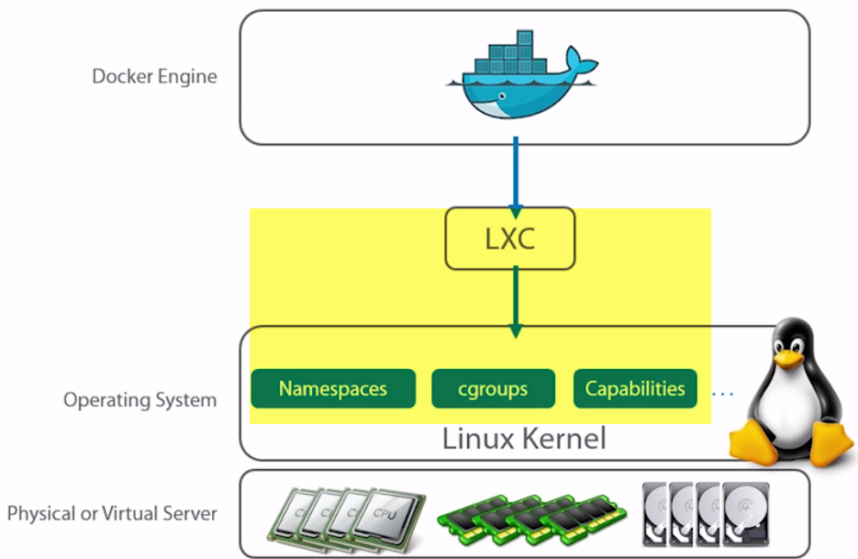

**Issues…. Lying on something, outside of your control as core component of your solution??not ideal**

**After: Docker Wrote libcontainer (replacement of LXC)..Gives direct access to kernel..**

**Namespace, capabilities.. They also shipped libcontainer with docker daemon.**

**Libcontainer potentially allow Docker togo crossplatform(linux, inc..windows also).**

**Now, libcontainer is default execution drive of Docker echo system…**

**---------------------------------------------------------------------------------**

**Devops_ 02_06-The Future of Docker and Containers**

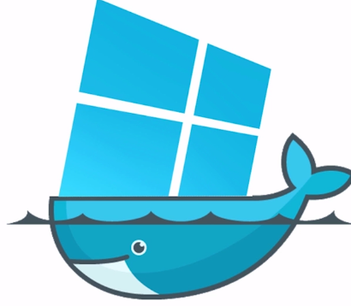

**Docker provides extremely std run time.**

**std run-time-🡪 Developers can code on Docker container on their laptops and take code and run it on VM in AWS, Azure, data center(bare metal)…, as long as Docker run time is there**

**Then why do we need docker on windows???No..it cant**

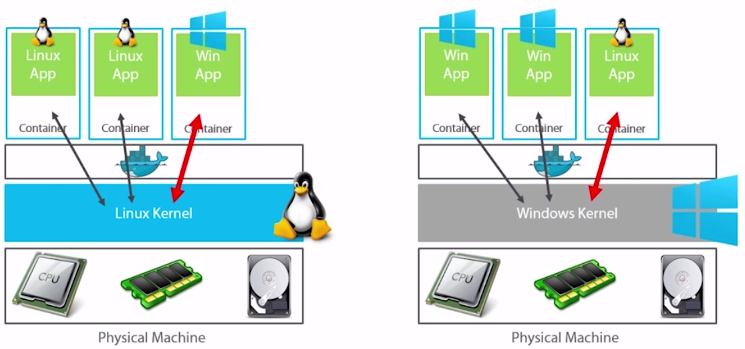

**Each Container share common kernel of host OS.**

**Container running on linux host m/c.., sees and use linux kernel of Linux host m/c.**

**Windows APP’s developed on windows docker container will only run on Windows host running docker …Linux app’s runs on windows kernel..**

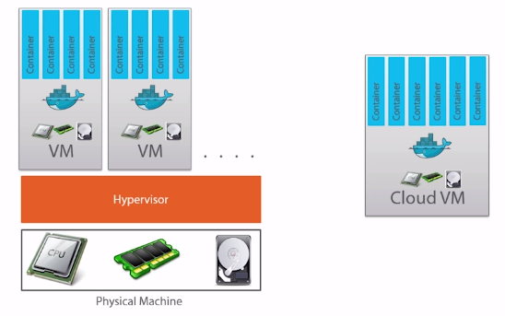

**Practical for lab/AWS(Ec2 instance).**

**Many people run docker container on top of virtual machines.**

**Future:**

**Drops overheads of VM, run linux on Bare metal of server**

**Container on top of linux**

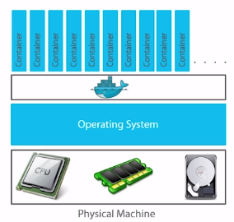

**-Far better efficiency…& all fat that exists in VM**

**Microservices architecture:**

**Applications are designed as smaller services. That collectively operate to form APP.**

**Each of these smaller component services runs as a single process inside it’s own container. These container and process then communicate together with eachother to form overall APP.**

**But each component service running in its own Container is individually upgradeble.. independent of all other components of overall application.**

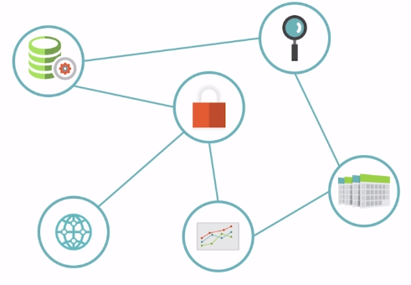

**This kind of application design seems to be future definitely for web scale applications.**

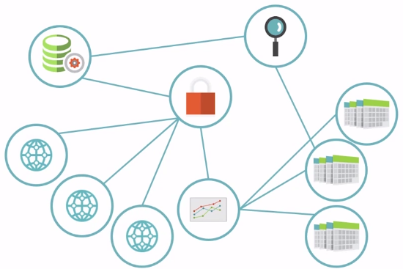

**But generally arguably. Superior architecture to monolithic application ..**



**Upgrading any one component is a huge piece of work. Usually involves:**

**-Ton of risk and**

**- healthy portion of Downtime.**

**Docker in containers seem to be perfect for this next Gen architecture..**

 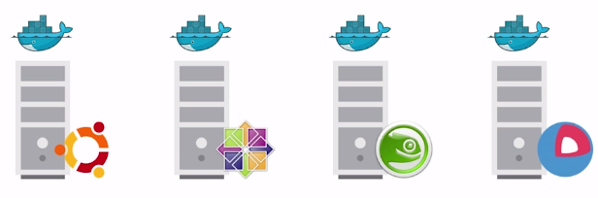

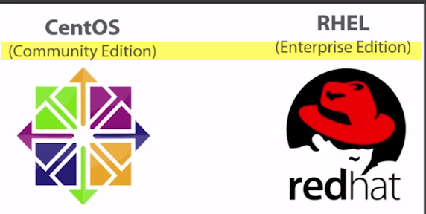



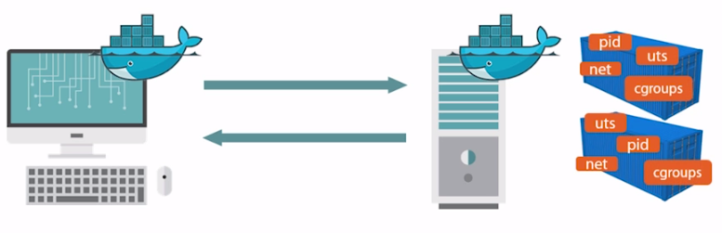

**Client server model where,**

**Docker Client: Docker Client sends commands to Docker daemon, and daemon responds..**

**Docker Daemon: Does hard work of creating containers, and constructing kernel namespaces, cgroups, capabilities. All these steps requires instantiating a container..**

**Together-🡪 Docker Engine (includes both client and daemon)**

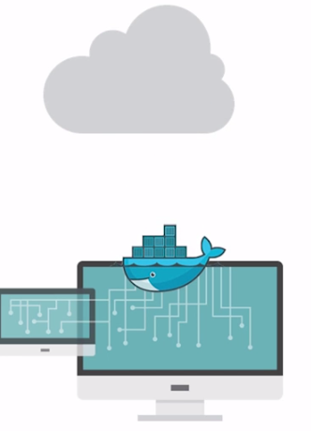

**Docker client and Daemon, installed as single package.SO we can run both on single server, or they can talk over network.**

**Requirements: 64bit**

**Kernel: Min: 3.8, (New: 3.10..Better for better support of namespace and stability).**

**Installation: yum install docker**

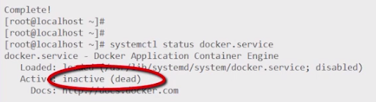

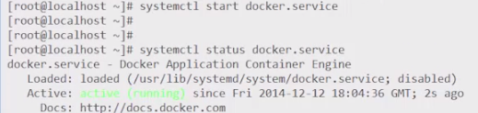

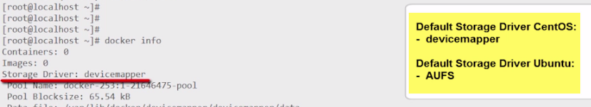

**Centos doesn’t use UFS, User libconatiner(not LXC)**

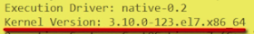

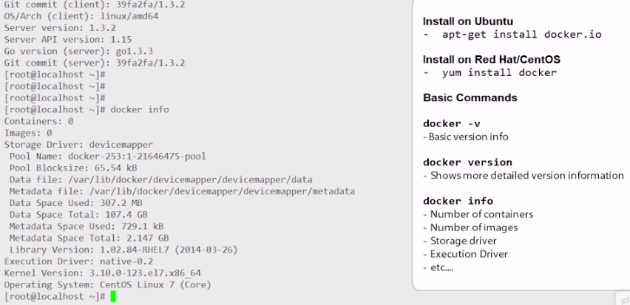

**Updating Docker:**

**Golden Rule: Might not work…Cloud, template based mutable infra.**



**Ubuntu:**

**docker –v**

**Add docker repo key to local apt key chain…This is from where we can get new version from..**

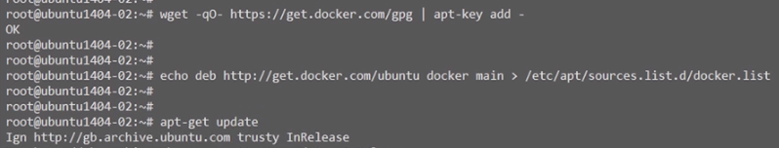

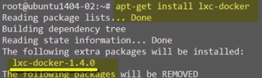

**Devops_ 04_05-Granting Docker Control to Nonroot Users**



**By Default, Docker Daemon listens on local Unix Socket**



**s-> Socket.. docker.sock is part of docker group.**

**Instead of root, we can add normal user to docker group.., which has ownership with socket.**

**Docker group has control over local unix socket=>We can grant normal users, ability you make & break containers without being root acces..**

**We can login as normal user, and no need to preface all docker cmds with sudo.**

**Adding normal users to docker group-🡪 security concern.**

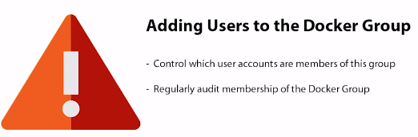

**FireUp(start) new container:**

**docker run -it ubuntu /bin/bash**

docker run-> start new container: it -> make interactive & assign tty

Place container on Ubuntu image Inside container run bash process( default)



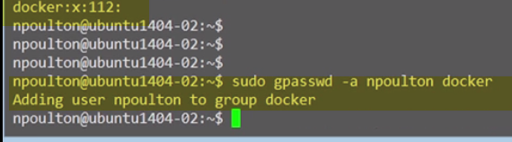

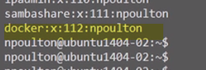

**Error: same**

**Group Membership get cached when login**

**Logoff( logout) -🡪 logon**

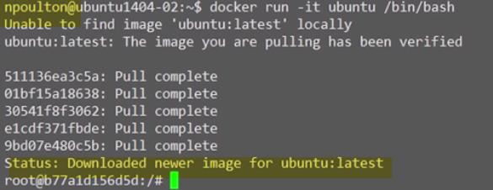

**Configure Docker Daemon on Ubuntu host to listen on network port instead of local Unix socket. Then connect from centos machine.1.)**

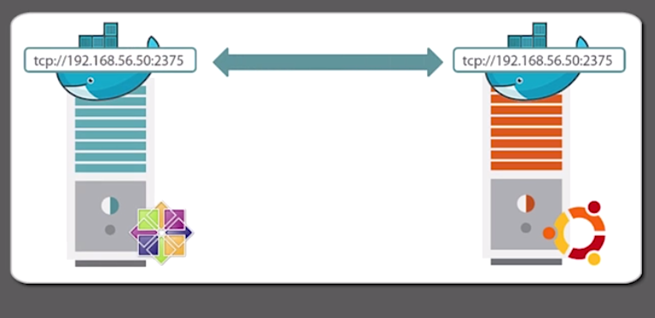

**2.) Docker –v**

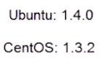

1. **Check if docker program listening on network**

**Netstat –tlp**

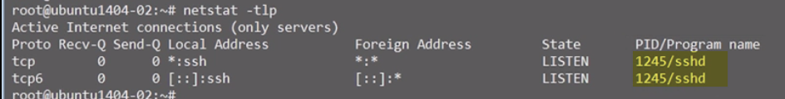

1. **Service docker stop**
2. **Now, we tell docker to listen on network, rather than socket.**

**Ubuntu: Docker –H 192.168.56.50:2375 –d &**

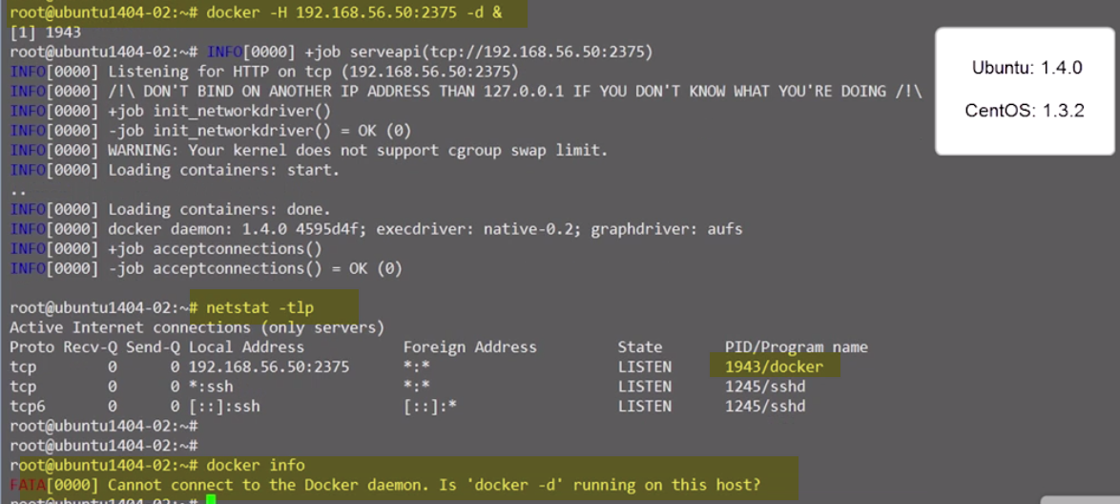

**Local client is still trying to talk to Docker-daeom on local unix socket.**

**Fail: bcz we are listening on n/w, not socket**

1. **centoS:**
2. **Docker client to talk to docker daemon over network**



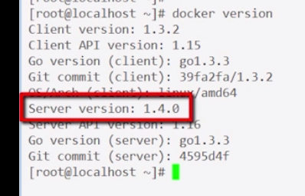

**1.4.0 for daemon of server,even on centos Host.Local version: 1.3.2**

**Happening bcz..Client to talking to remote docker daemon on Ubnuntu host over network**

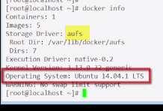

1. **Check firewall if nay issues**

**9.)**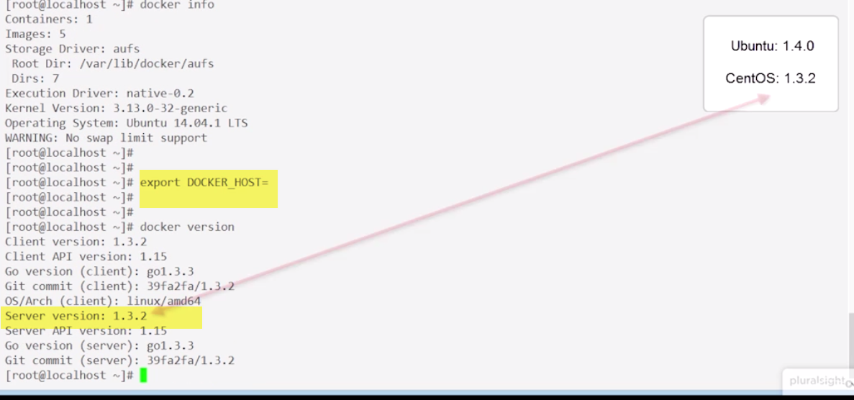

**Now, Docker client is talking to local daemon version**

**Note: Binds daemon to n/w port. Potentially allows anyone to connect to daemon.**

**Remember, when listening on local unix socket, that socket is restricted to root,docker group …not so with this network port.**

**We can also bind with socket and n/w port also using -H**

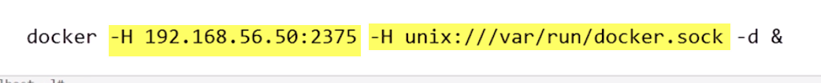

**Devops_04_07-Playing Around with Our First Docker Container**

**Google information server**

**Ping 8.8.8.8**

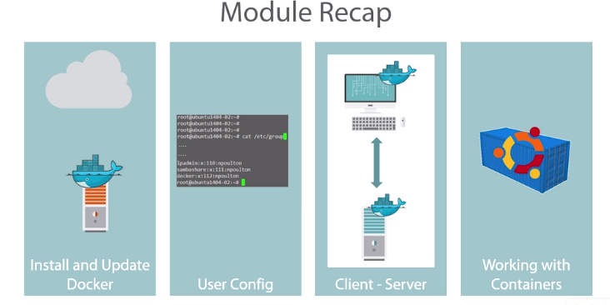

**Add std user a/c to docker group…so giving full control to Docker socket, daemon**

**How docker daemon and client communicate over n/w…,instead of local Unix socket..**

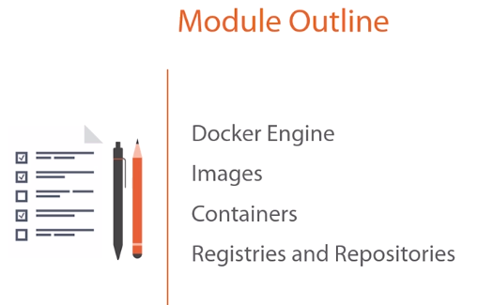



**Docker Daemon/Docker Engine/Docker run time**

A **shipyard** (also called a dockyard) is a place where **ships** are repaired and built. These can be yachts, military vessels, cruise liners or other cargo or passenger **ships**.

A **manifest** or customs **manifest** or "cargo document" is a document listing the cargo, passengers, and crew of a **ship**, aircraft, or vehicle, for the use of customs and other officials.

Cargo: All articles, goods, materials, merchandise, or wares carried onboard an aircraft, ship, train, or truck, and for which an air waybill, or bill of lading, or other receipt is issued by the carrier.

Container:

A container image is a lightweight, stand-alone, executable package of a piece of software that includes everything needed to run it: code, runtime, system tools, system libraries, settings. Available for both Linux and Windows based apps, containerized software will always run the same, regardless of the environment. Containers isolate software from its surroundings, for example differences between development and staging environments and help reduce conflicts between teams running different software on the same infrastructure.

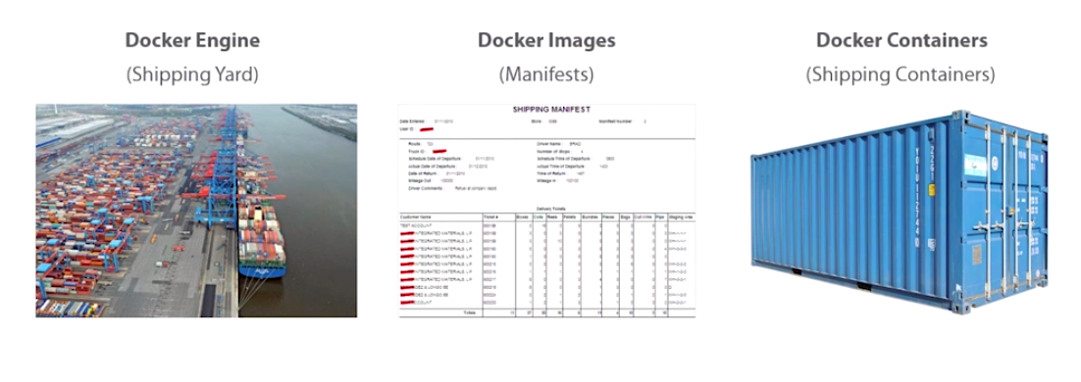

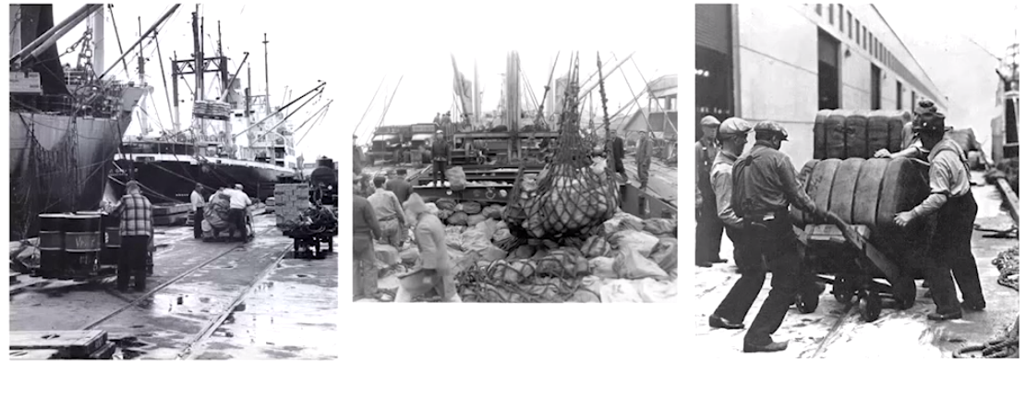

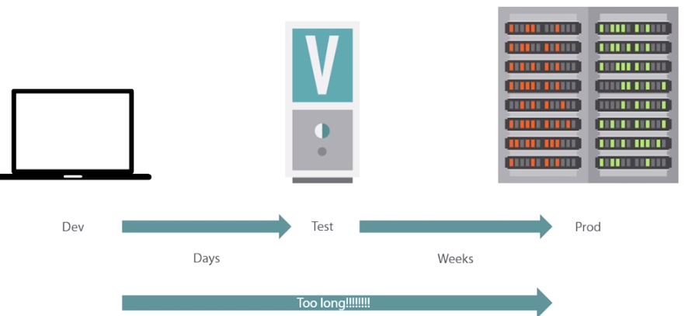

1. **Docker Engine.**

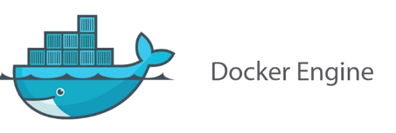

**This is what we installed using apt-get install docker-io /lXC-docker --ubuntu**

**Yum install docker (centos).**

**This docker program is installed on each docker host to provide docker environment, and access to all docker services.**

**In our terminology Docker Daemon -> shipping yard**

**Infrastructure needed to import and export goods**

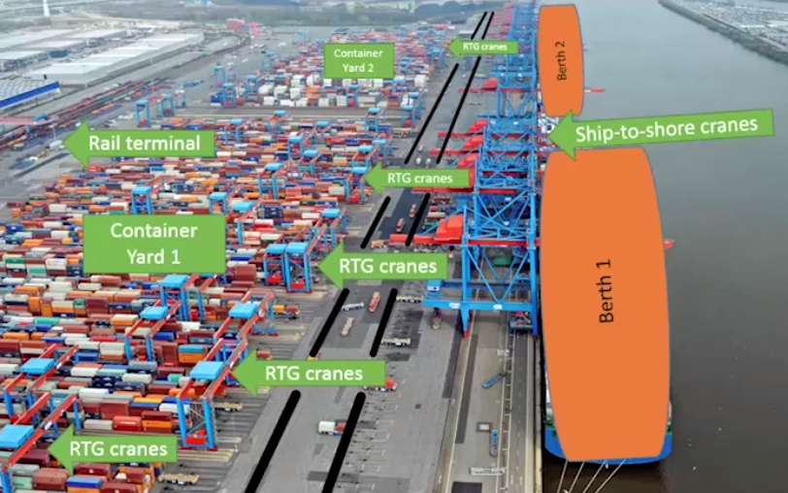

**All these things make up shipping yard.**

**Docker-> Application infrastructure and run-time dependencies**

**Root file system**

**Process hirerarchies**

**Network stacks**

**Variables access to kernel and features**

**Resource allocation.**

**It’s all standardized…All look same one docker install to other**

**Or One docker host to another**

**Shipping yard->Std dimensions, size, common place in yard**

**Std capcity,std control mechanism..**

**All below are standardized.**

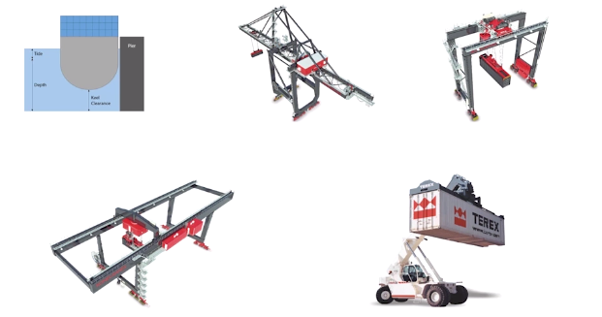



|  |
| --- |
| **As long as run-time environment provided by container technology is same,**  **No matter what underlying platform VMs on laptop, Bare metal, data center or instances on cloud…, as long as container run-time is same.You can run application on it.. No changes required** |

|  |  |  |
| --- | --- | --- |
|  |  |  |

**We build on docker container (say lappy)…, we can genuinely transfer to other environment…like AWS etc…, As long as target environment is running docker run-time.**

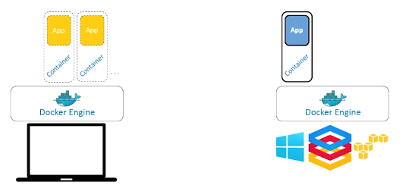

**Ex: Developing Apps for android phone..It works for any android device tablet,etc**

**Standardized shipping yard/Standardized runtime environment that looks and fell same, no matter platform it is running on..It makes application portability insanely simple.**

**2.) Docker Images**

**-like shipping manifests**

**Containing list of everything in a container + instructions on how to build it.**

**Kind of Static/frozen versions of containers**

**Contains all data, metadata to fire up container..**

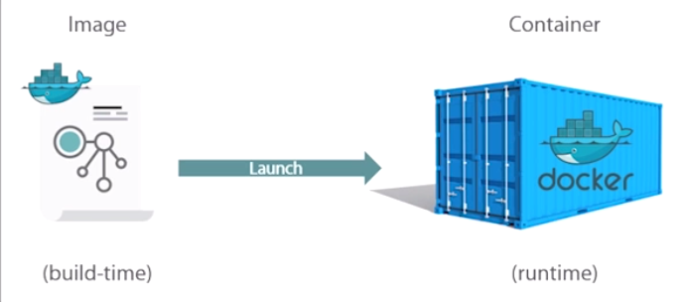

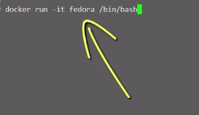**Tells which image to place conatiner on.**

**This container is based on fedora image=> it will run fedora OS.**

**Without specifying OS, we can launch container**

**(launching fedora based container…,Ubuntu based container)**

**Images are like templates in real-machine world**

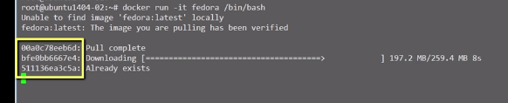

**Images is comparised of layers..These 3 numbers are 3 layers that comprise fedora base image we are downloading..**

**Fedora: latest :**

**We are downloading from dockerhub—Public docker registry.**

**On docker hub, there can be bunches of versions of fedora. In docker run time command.., if we specify fedora only, it grabs latest**

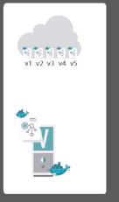

**Docker pull: Pull images on docker hub & store them locally.**

**We don’t need to wait for download.**

**Docker pull fedora--🡪 latest**

**Docker pull –a fedora -🡪 pull all feora images from docker hub and store local host**

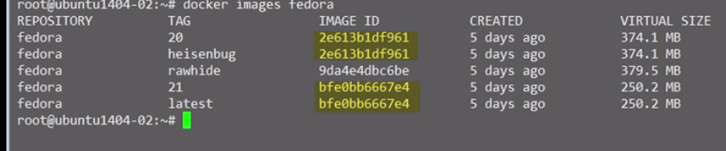

**5 different version of fedora.. But actually only 3 versions(3 different image ids)**

**If we compare Image ID column, with TAG column,**

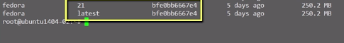

**Latest version is same as with TAG 21=> Latest/21 is stable image.**

**Each image have 1 tag, and can have more.**



**----Ubuntu**

1. **Docker COntainers**

**Containers are launched from images**

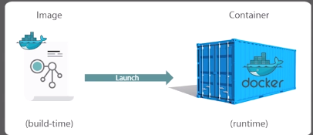**Running instances of images**

**-Images are build –time constructs.**

**-Containers are run-time constructs of images.**

**We used:**  **command to launch container.**

**Docker goes and grab image we specify, unpacks it, stacks all layers and build into running container.**

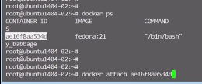

**Containers are bare-bound run-time…Just the things needed to provide a functioning working run-time and pretty much.. nothing else**



**We can exit conatiner, without killing**

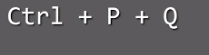

1. **Docker Hub**



**We pull images from repo. Repos live inside registries.**

**Default public registry: Docker hub..**

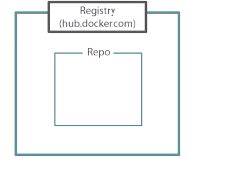

**In Docker hub registry, bunch of repos .In Repo’s we have different images..**

**Ubuntu->12.04,14.04 etc..**

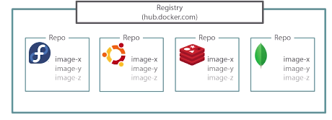

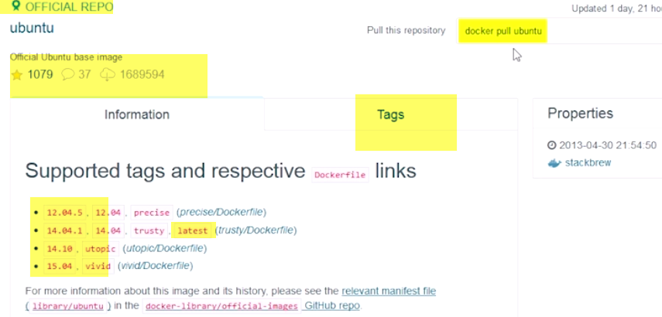

**Dockerhub is official public registry, like Googleplay for android**

**appstore for iphone**

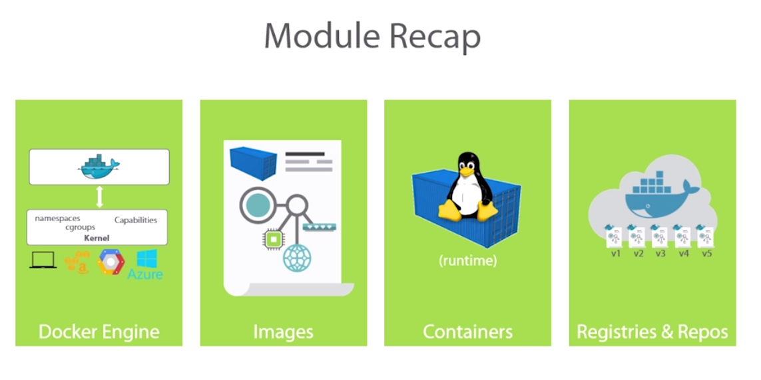

**Docker Engine: Provides basic infrastructure required on our hosts to be able to run containers.**

**It gives access to all kernel-features.**

**No Matter what platform we run it on..,laptop, VM, Cloud,bare metal.., we get same docker look and feel**

**This makes our container uber portable.**

**Docker Images**

**Kind of static on-disk definition of container.**

**They contain all data and metadata required to start a running container.**

**We launch containers from images.**

**So, if we launch container from Ubuntu-based image, we get container running Ubuntu OS. Image size coreOS-20 MB.**

**We saw How images are tagged .., so We can have multiple versions of Same OS within a repository. Ubuntu 12.04,14.04 different versions.**

**-Kind of light, static, frozen containers**

**Containers:**

**If images are build-time constructs.. then conatiners are run-time constructs from images.**

**A container is basically running instance of image.**

**We can start, stop, attach..etc**

**Resgistries and repos**

**- Docker hub**

**-Ubuntu repo**



**Layering/Stacking:**

|  |  |
| --- | --- |
|  |  |

**We stack one image on top of another.. So we got 3 layers-🡪 form single image.**

**Single image comprised of 3 layered images.**

**Layer-1-> Rootfs: Base image-> All files are dir required to make up container stripped down base min OS.**

**For ex: For Ubuntu-based container: All files and dir.. Required to make container look & feel just like Ubuntu OS.**

**layer2->On top of that, say we installed application-nginx**

**Layer-3-> update or config files change**

**Why 3 images on top of other??Why not 1 image with everything inside it.**

**Let say: We take Base image Ubuntu 14.04 from doker hub, 6 months ago.., we put nginx on it-> so we added that layer to image🡪 later changes layer-3**

**This layered image is absolute flexible bizzo for configuration management.**

**We can keep clean image..On base image, we can add super thin layers(for any config stuff).. We never have nightmare of crack open golden image..**

**This Ubuntu image can be shared with multiple conatiners on our docker hosts**

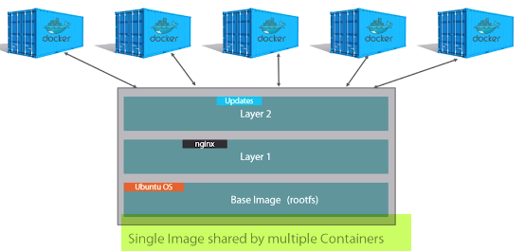

* **Really efficient in disk and cache space..**
* **Really efficient to make config changes..**
* **No need to crack open single large monolithic image and shover new changes in..**

**Need to make changes???Just add to layer.. Mix all of these together with bit of puppet/chef to help increase**

**Each layer or image member get its own ID.**

**These IDs are listed inside of our Docker image+ some metadata, which tells docker how to build container at run time.**

**Metadata says: Put layer image abc on bottom(layer-1)—Parent or base image**

**, Layer image def on top of that ,layer image ghi on top of that…, these get cmbined into a single view**

**Single combined view of all layers.**

**Higher layer always win in terms of conflict..**

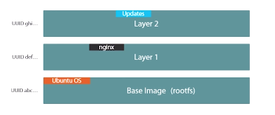

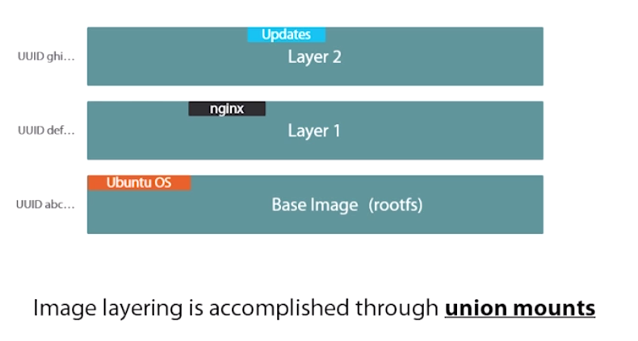

**The ability to mount multiple FS on top of each other using union mounts**

**Ex: using union mount, instead of mounting one f fs say root and other fs say /home.Union mount helps mounting multiple fs over top of each other.**

**But combine all of multiple layers into single view, giving us application/OS look and feel like regular OS.**

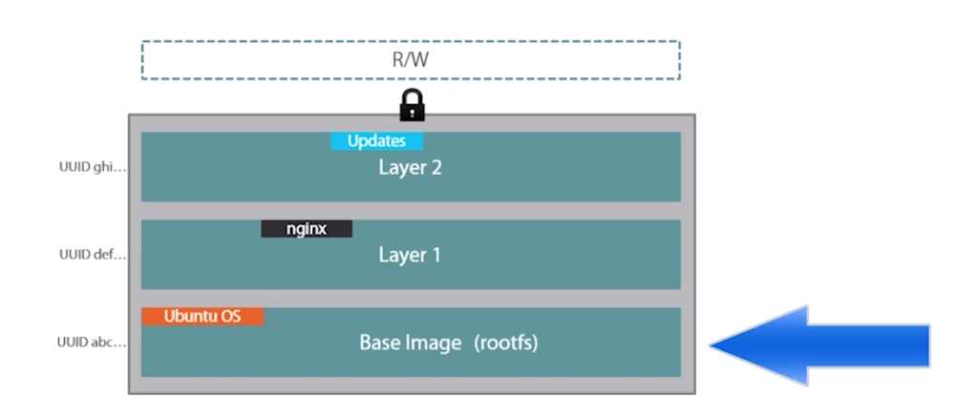

**The way docker rolls with union mounts is, all of these layers in images are mounted as read-only. Only top layer(additional layer created when we launch container) is only writable layer. So with docker its only top layer is vitable.**

**We said our base image at bottom has rootfs or root filer system. Sometimes there is one layer below that bootfs.**

**When we start container,there is bootfs exists below rootfs. bootfs is very short lived. It doesn’t live once container started.**

**(in short admins or developers doesnt need to deal with it).**

**There is no bios/machine level code located in compressing kernel. Kernel is already botted right. So we share same kernel among all running containers.**

**Images are stacked/layered. They uses union mounts. ufs is default union mount implementation used on Ubuntu hosts running docker.**

**Only very top layer is ever writable, and all changes to running container on run-time are committed to top layer via copy-on-write behavior.**

**If we need to update file in one of lower read-only layers, we need to first copy on to top layer and store any changes made to it ..right there in top layer..**

**Where are images stored??**

**Docker images🡪 we get images that are stored locally.**

**When we download these, each download appear to be downloading multiple layers.**

**Each of these is a layer, that form CoreOS-apache image**

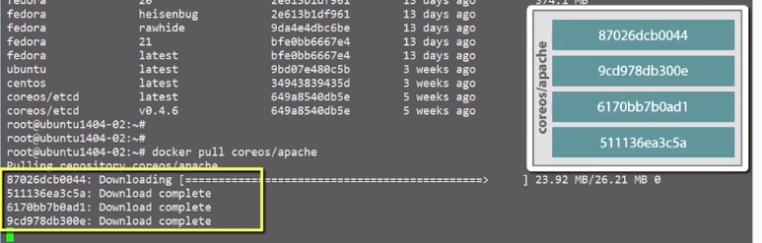

**Docker images –tree**

**Visual of how images and layers are linked..**

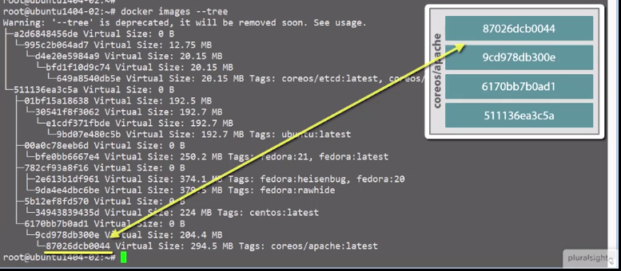

870-> top layer of CoreOS is linked with imager layer starting with 9cd-> 671->511..

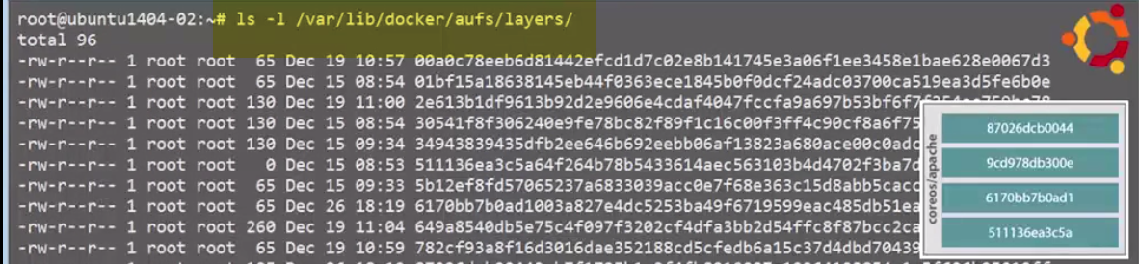

Images layers stored locally..Ex; 870  
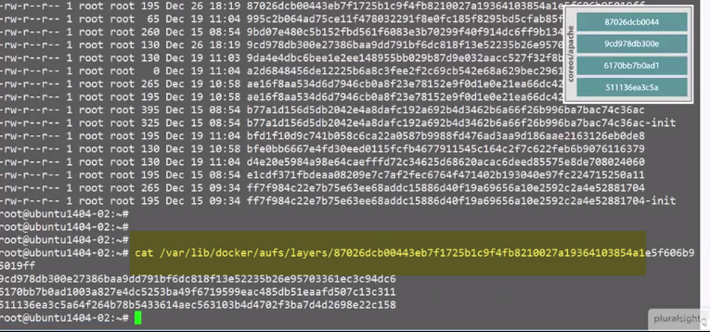

Listing 3 layers of coreOS image.It’s listing in order they are stacked

9cd:-🡪 2 layers, 617🡪 1 layer , 51---no layers below that

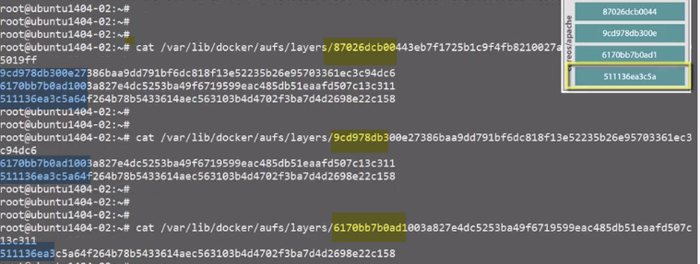

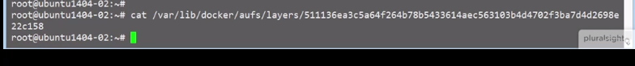

**We can see relation-ship b/w layers with –tree/ pumble around host file system and check actual metadata.**

**We can also use docker history command. Lets look at top layer of coreos**

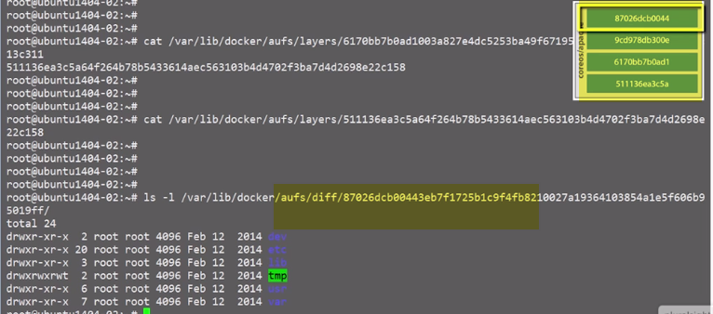

**6 dirs..Those are actual files & dir that makes actual coreos docker images.**

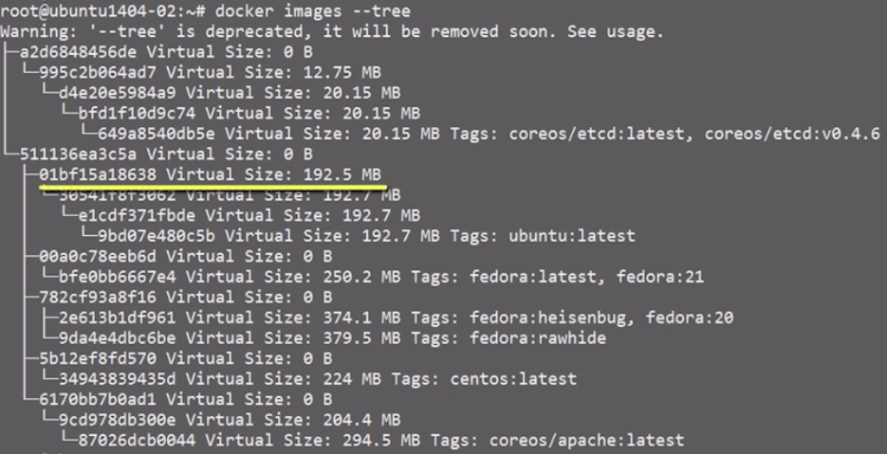

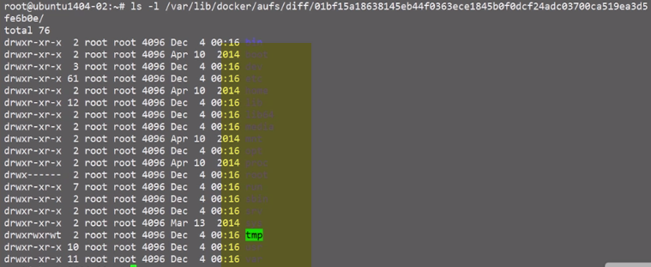

**Looks like ubuntu root FS. Minimum set of files required to spin up Ubuntu OS.**

**Devops_ 06_05-Copying Images to Other Hosts**

**Move docker container from one docker host to other..**

**Later, can see pushing container images to dockerhub and downloading from dockerhub on another host.**

**Now, manually save container image to tar file, export from 1 centos host, and import from another centos docker host..**

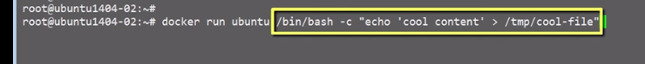

**Started container…,and created a file with single line of content in it..**

**Then container exited..**

**No –it flags.**

**1.)cmd running inside container is short-lived command.**

**It runs, as soon as it completes..process ends and container exists..So no need to run interactive shell on it.**

1. **Most command way of running container is detached mode…as above**

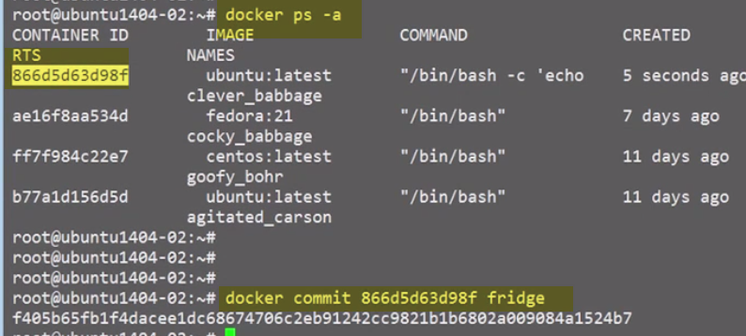

**Its created a new image from changes we just made inside container.**

**Docker commit takes changes we made and creates a new image. We call that image as fridge**

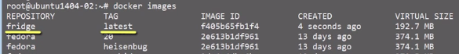

**Automatically tagged as latest, with name specified—fridge**

**Docker images –tree**

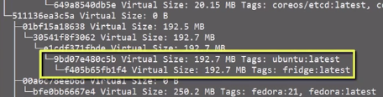

**We can see.. fridge Based on Ubuntu images**

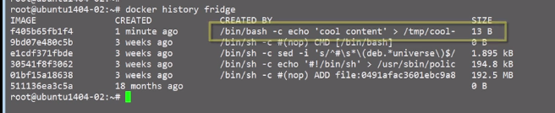

**We can see commands used to create image fridge.. Size just 13bytes.**

**All these are read-only. We get one vitable top layer. Point being.. We could have 10,100 containers all sharing same Ubuntu base & thin layer..**

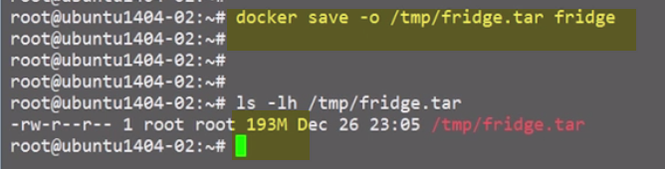

**Now copy file top another centos host.**

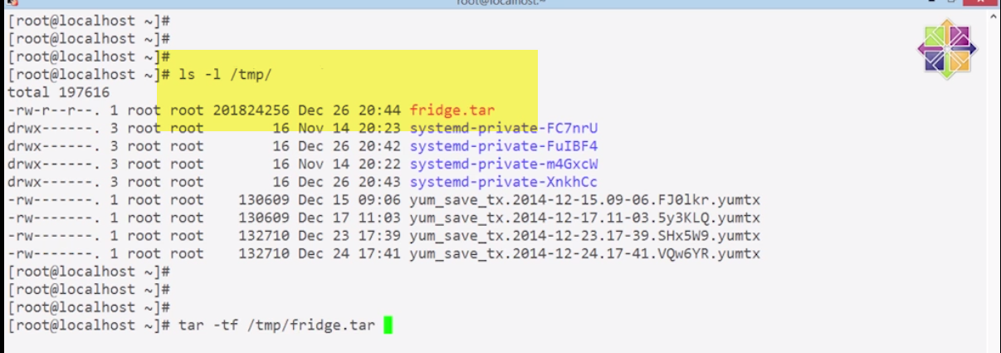

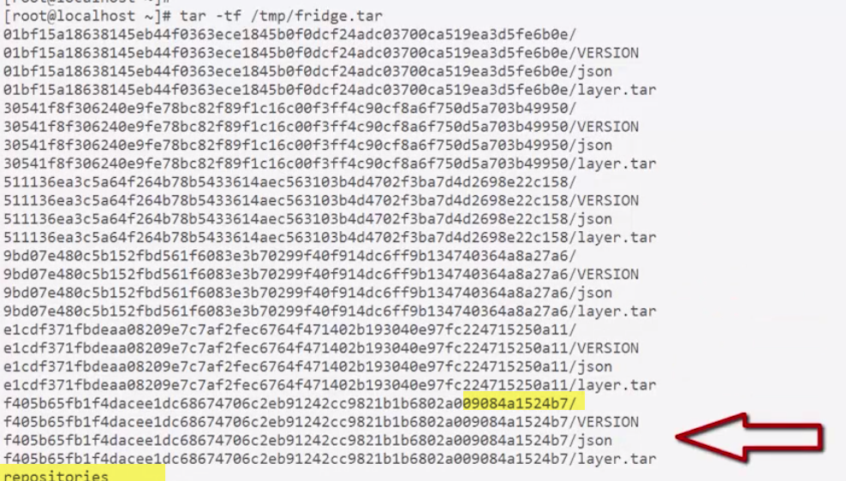

**6 Dirs, each with these files in🡪 version file, json,layer.tar**

**And at bottom file called repositories..**

**Dir for each image layer🡪 which have metadata and tar bar with actual data inside it..**

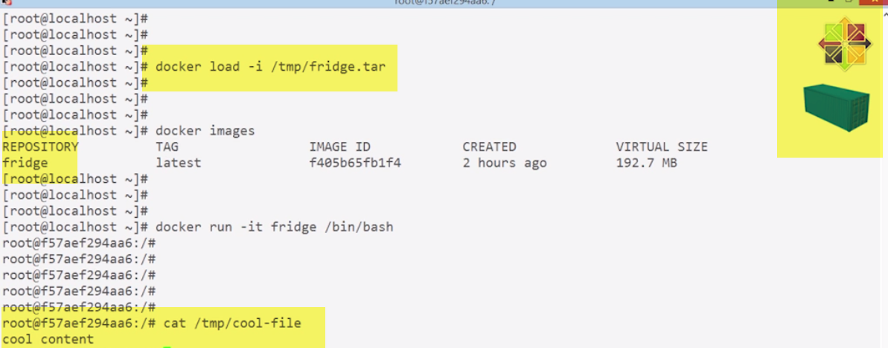

**Commit->to commit changes made in a container to new image**

**Save->export image to tar ball**

**Load-> import image from tar ball**

**Devops_____06_06-The Top Writeable Layer of Containers**

**Image-> build time constructs**

**Containers-> run time constructs.**

**Images are used to launch containers. So, containers are like run-time instances of images.**

**When we launch containers using docker daemon, daemon reads the image and metadata and builds container by stacking different image layers..**

**It stacks them as per information in metadata**

|  |  |
| --- | --- |
|  |  |

**Each and every container gets its own thin writable layer, right on top of read-only image layers**

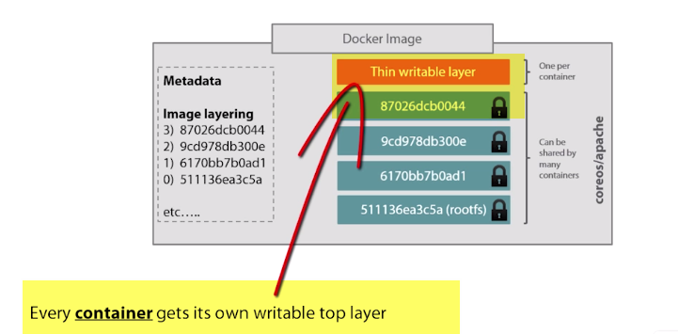

**This writable layer is all changes to container to be made..**

* **Installing & updating applications**
* **Writing new files**
* **Config files like ip addrss.., whatever …It all goes on top layer**

**Container state is stored in thin layer.**

**It is initially empty.It consumes space,as and when we make changes to container**

**Interesting: Rootfs is never made writable.**

**In boot process, rootfs is mounted initially as read-only..then later in boot process remounted as R-W.**

**This never happens with conatiners. Rootfs,right down at bottom of container is locked, and read-only.**

**Thanks to magic of union mounts…,top thin writable layer gives look and fell of regular writable root file system..**

|  |
| --- |
| **All conatiners on single sytem share kernel of host os..**  **In consideration of APPS: They got linux run-time environment in which they can execute.**  **Developer/Admin: Each container is fully sand-boxed runtime execution environment for our applications..** |

**Devops___06_07-One Process per Container**

**Container runs single app/single process.**

**It’s good for web-scale apps and micro service architecture.**

**When process running inside container exists.., so as container..**

**Ex-1: Previous ex: (Launch-> executed command-> exited)**

**Ex-2:** 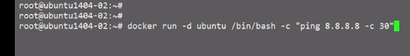

On enter: conatiner should launch**,ping goes to google DNS server 30 times** and exits.

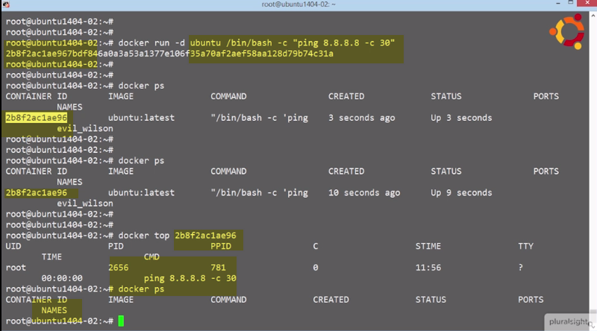

1. 2b8f🡪conatiner uuid
2. Docker ps🡪 2b8f(running) and name evil_wilson
3. Docker ps-> still running(still pinging google)
4. Docker top uuid 🡪 shows top running procerss inside our conatiner(ping process here)
5. Docker ps🡪 exited.

Now, container Launched-> fire ping 30 tmes->exited

1. Docker ps –a

Recently exited..



**Ex-3:** for hhtpd: httpd process exited-> so as container..

Container exits as long as one of process inside it exists..

Explicit image:

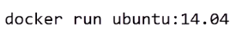

**Devops______06_08-Commands for Working with Containers**

Control how many cpu shares, a container can get..

1024🡪 full access to all cpu shares. 256-> quarter

All container on host will get equal cpu shares by default..

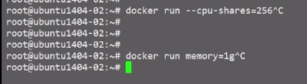

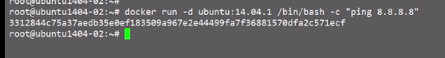

1. We get conatiner ID-3312
2. 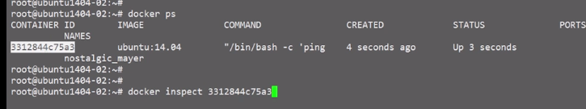

Docker ps🡪 still running

1. Docker inspect ID

We can get detailed info. Of container..

We can run docker inspect against image IDs too…

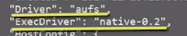Storage driver

Execution driver..,Network settings etc..

1. Docker ps🡪 still running
2. Docker attach conatiner (attach to detached container)

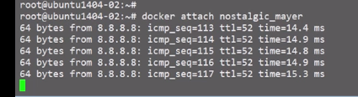

Ping command doing job here..

If we press ctrl+c->dropped out of conatiner-🡪 process stopped-> container exits

-----------------------Wrapup----------------------

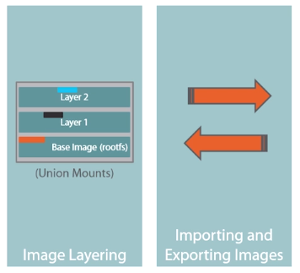

1. **Images**

Image layering: How docker imagers comprised of mutiple layered images..

All these get combined together to give look,feel,smell like normal FS using Union mount technologies..

Which allows multiple FS to be mounted over eachother/top of each other

1. Where images are stored in docker host machine

And how we can export/import to other host machines..

**Containers:**

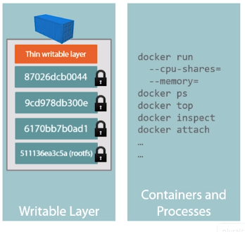

1.)Docker engine reads metadata in docker image and stacks image layers according to instructions in metadata.

2.)**Major feature of conatiners:**Thin writable layer gets over-layed on top of image layers.

It’s thin writable layer on top..that all run time changes of container gets written to.

3.)Conatiner related cmds:

How conatiners usually have single process running inside of them.

Process exists🡪 so as conatiner

**07_Conatiner management**

**07_01-Module Intro:**

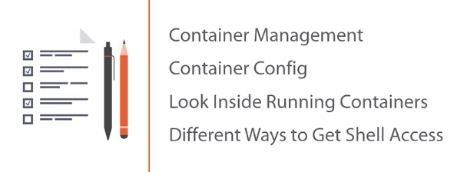

**07_02-Starting and Stopping Containers**

Containers are like kind of light linux machines. Each one gets its own sand-boxed FS,networking,Process tree.It gives all std linux environment to execute APPS.

Just like linux machines,containers can be started/stop/restarted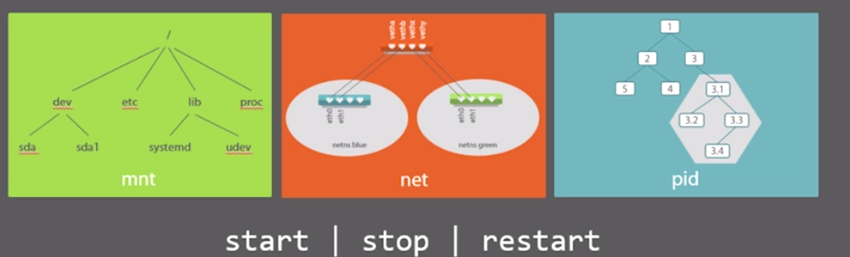

Note: we use terminology start,rather than boot container.



Exit🡪 stops container.

**To return to docker host, without stopping conatiner-> Ctrl+P+Q**

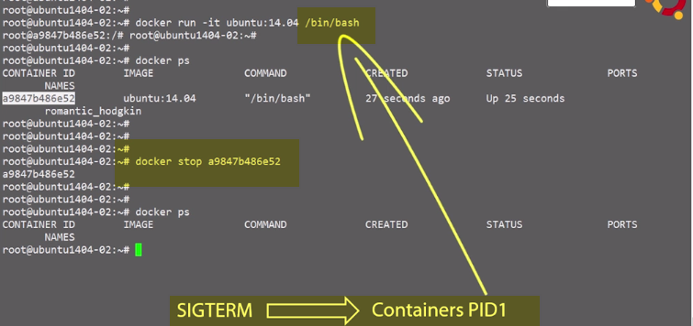

Docker stop comand sends SIGTEM(gracefully terminate) to process with **PID1,running inside container.**

**Tht’s the process(/bin/bash) we told container to run at the end of docker run command.**

Docker container terminates,when process within them PID1 terminates.

We can also do docker kill,sends SIGKILL(bruteforce/forcefully) rather than SIGTERM.

Using docker kill, we can specify any posix signal we want to send to container PID1.



Rem: SIGTERM/SIGKILL-> Goes to the process inside the conatiner running with PID1

docker ps -l---> last cnatiner exited



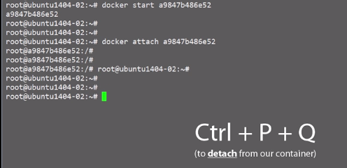

Docker attach cmd-> attches PID1 inside the container

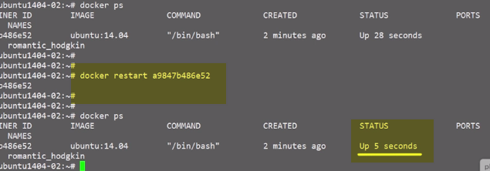

07_03-PID 1 and Containers

PID1-> Process we specifty at end of docker run command.We are rocking with /bin/bash

Linux world-> PID1 is a special process called init. Init is mother of all processes.All processes are forked from init or child of init.

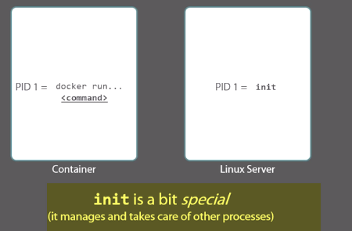

PID1/init receives signal to terminate.It makes sure other process in system cleanedup gracefully as possible; ensuring not only graceful shutdown in init itself but also also processes.

Realtime: instead of bash—MangoDB,ngnix…But these are not designed to be as init process.

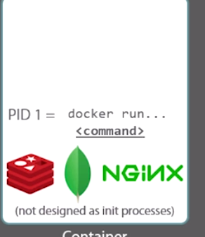

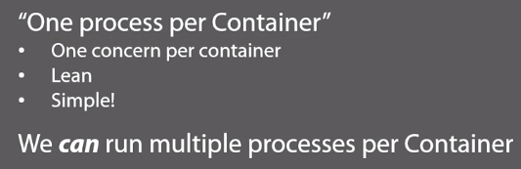

07_04-Deleting Containers

Running ctx can be stopped & stopped ctx can be restrated.

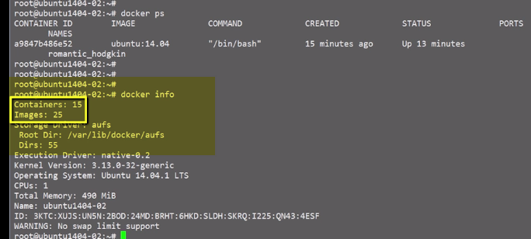

We have 15 conainers,25 images..

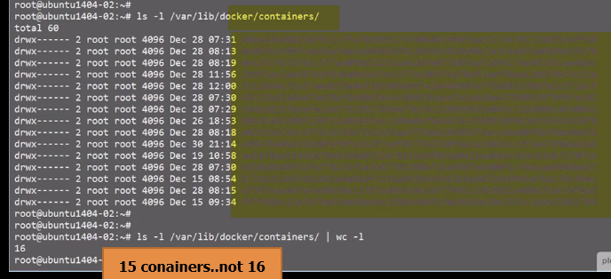

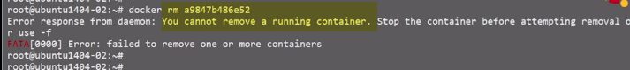

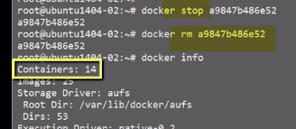

We have 14 conatiners now..

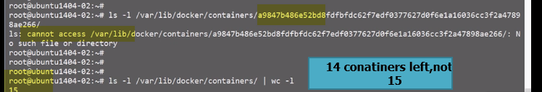

Delete running conatiner –f-> force doker rm –force

Alias: 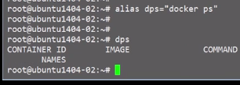

07_05-Looking Inside of Containers

Docker top ID-> To know what process running inside ctx from outside.

We run 1 process in conatiner.

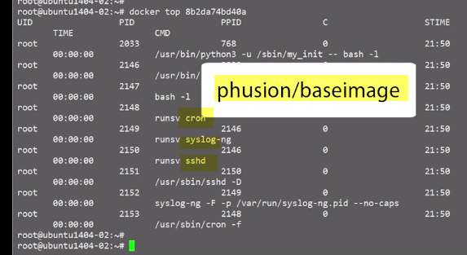

This container is based on phusion/baseimage-Ubuntu based.

If we need to run more than 1 process inside conatiner🡪 check this.



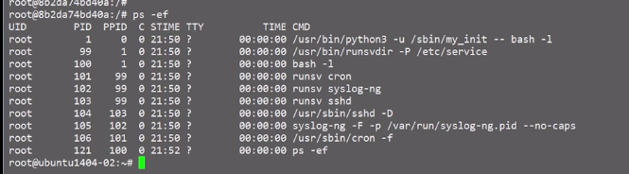

07_06-Lowlevel Container Info

D Inspect -> gives great low level info. About conatiner or images..

Docker inspect image/conatinerID…

Info we get using inspect for conatiner/image is same

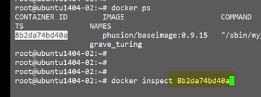

State of conatiner:

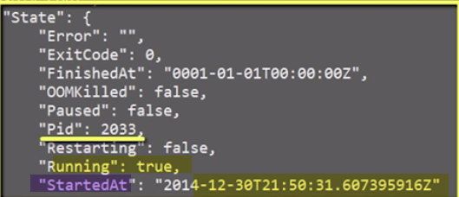

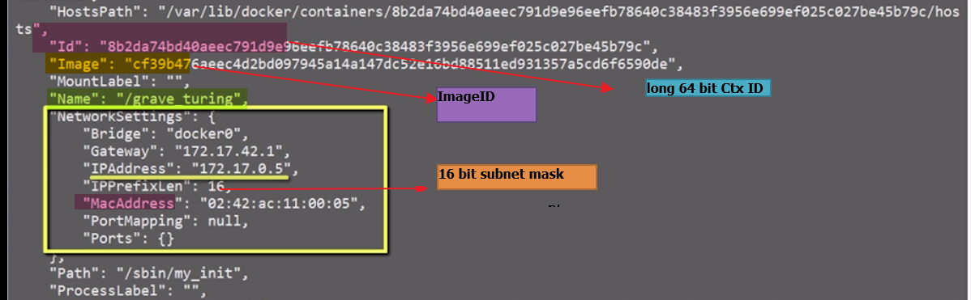

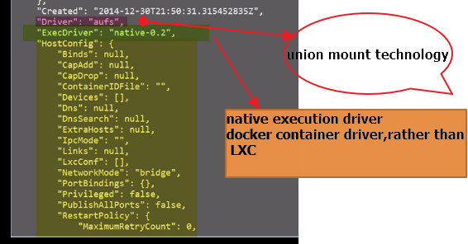

Behind scenes: This info. Is pulled from couple of Json files

- config.json

-hostconfig.json

Both of these exists in container directory on our docker host machine

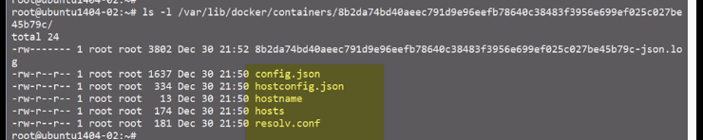

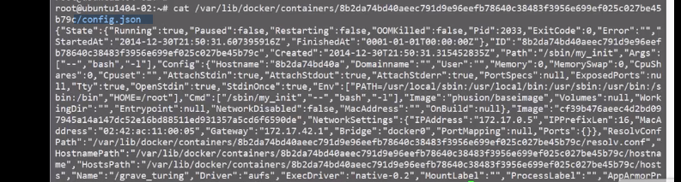

Data Stored as key store array..

07_07-Getting a Shell in a Container

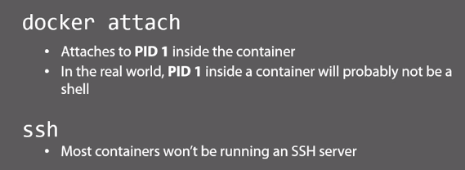

Instead of /bvin/bash,there will be appl. Like apache in real world

Nsenter(namespace enter)

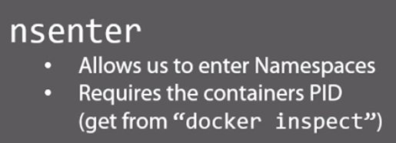

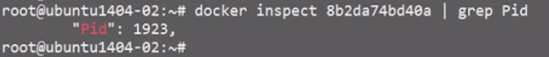

1. We got container PID
2. 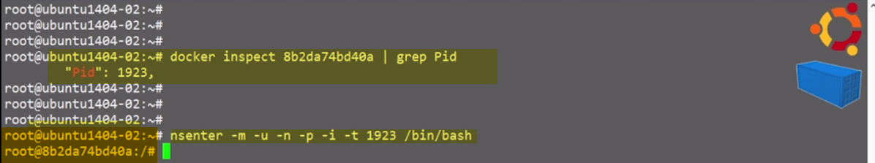

We are telling nscenter to enter

m->mount namespace

u->uts namespace

n->network namespace

p->process namespace

i-> ipc namespace

t->target

1923->pid here

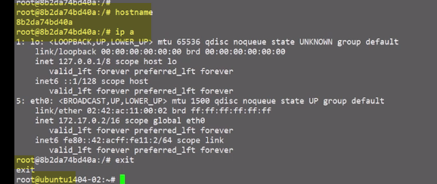  
Here, we are not attached to container of PID1,even when we exit🡪only logsoff

Conatiner still running…

This is difference with docker attach.

4.) 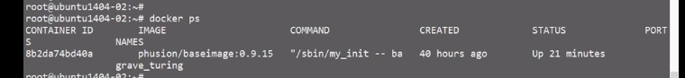

5.) Docker-enter containerID/funkyname

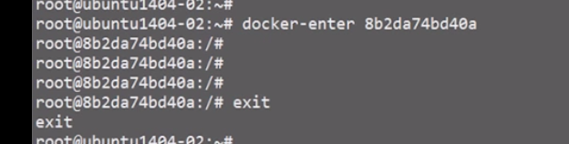 6.) 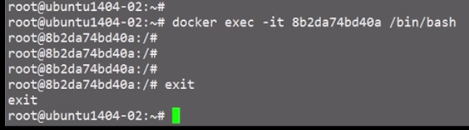

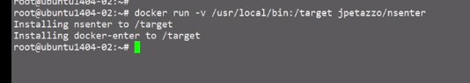

-v-> bind mount volume

Conatiner on: jpertazzo/nscenter container

Copy nscenter commands to /usr/local/bin

07_08-Wrapup

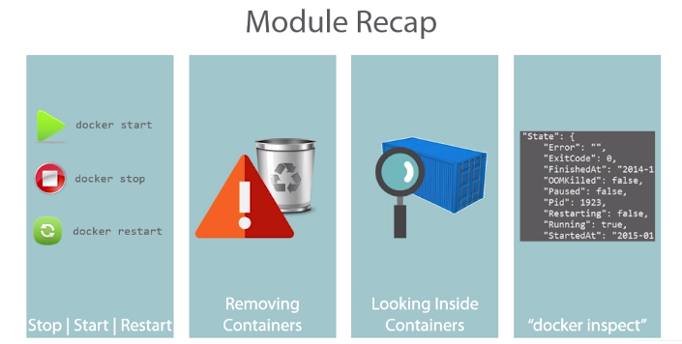

1. When restart->It picks from where it is left off
2. Where they get stored on docker FS.

We cant accidently remove running ctx.

1. Process inside ctx.

–How we run 1 process inside container

–If wanted can run more

Docker top,docker logs -> to see what’s going on inside container

1. Docker inspect: low level info about ctx and images

Devops___08. Building from a Dockerfile

08_01-Module Intro

How to build docker images using dockerfile.

Earlier: We created image using D comit cmd.But, powerful way to create image is from dockerfile.

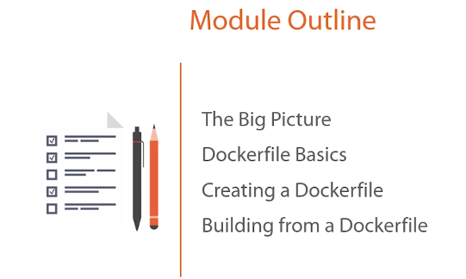

08_02-Introducing the Dockerfile

Dockerfile, notdockerfile/dockerFILE/DOCKERFILE ..etc

-Regular text file

-simple format (human readable).

Instructions are read from top to bottom, from left to right.

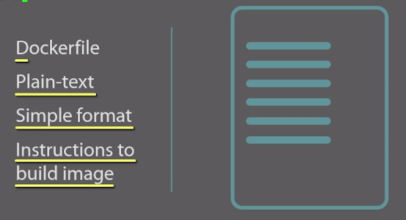

Once Dockerfile is created,we run docker build command to build new image from Dockerfile.

08_03-Creating a Dockerfile

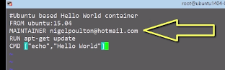

1.)#->comment

2.)FROM->It has to be 1st instruction in Dockerfile. It tells which image, we base this image on.

It’s always good practice to be specific of image version used. If version doesn’t not specified,it will be tagged as latest.It can be changed from time to time.

3.)MAINTAINER-🡪my email address..Can go anywhere in Dfile. **But good practice to capitalize instructions.**

Aside from comment lines and blank lines,all other lines follow format

Instruction followed by upper case, and value

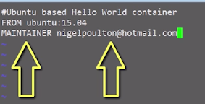

1. RUN apt-get update

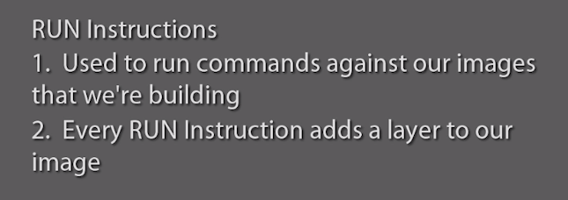

We have 3 RUN instructions=>3 layers of image.

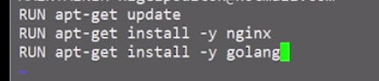

1st RUN->Create container-> execute apt-get update->stop container->commit change to new image layer

2nd RUN->launches new container from new image which is committed->executes apt-get install ngnix->->stop container->commit change to new image layer

3rd/Every Run-> Launch container->Exexute->Commit new layer

10 RUN commands->10 layers..

1. CMD(“echo”,”hello world”)

Command to print hellow world , everytime we launch container from this image.

08_04-Building an Image from a Dockerfile

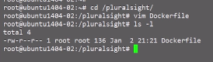

Nothing else in directory though..

When we build images from Dockerfile, any file/dir in same dir of Dockerfile will get included in build.

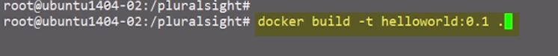

-t-> to add any tag to image

We can’t use upper case letters from naming docker images.

This will build new docker image,called helloworld, tagged as 0.1 ,and build according to Dockerfile in our current directory.

1. Sending build context to Docker daemon(just 2k)

Build context here, is files & Dir in the dir without Dockerfile.

It’s clearly Docker daemon, not client does the build. We are running daemon & client on same m/c.

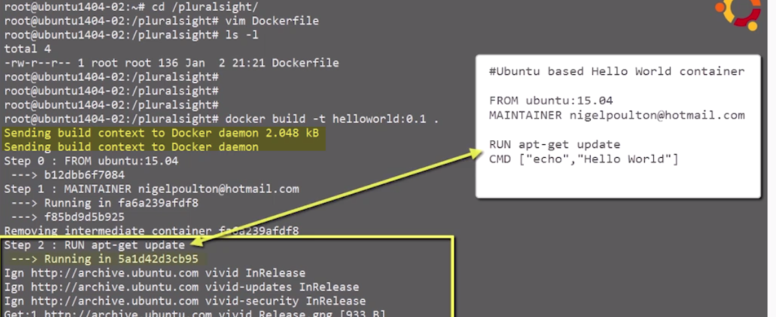

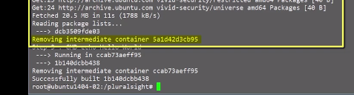

1. Step-0: FROM Ubuntu 15.04
2. Step-1: Maintainer,

Spins/Runs container

Commit new image layer

Removes container

1. Step-2: Apt-get update

Spins up new container

Receive o/p of apt-get update

New image layer created

Container deleted

1. Step-3: echo helloworld

-spin up new conatiner

-write up command

-writeup new image

-delete container

1. Successfully built.

1b14-> new image ID

Note: It’s containers that are deletd,not images..We keep image layers

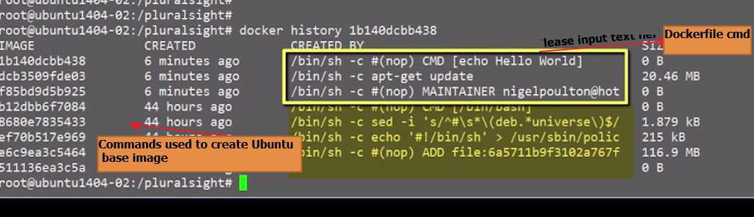

08_05-Inspecting a Dockerfile from Docker Hub

Dockerhub->Ubuntu official->15.04->Dockerfile

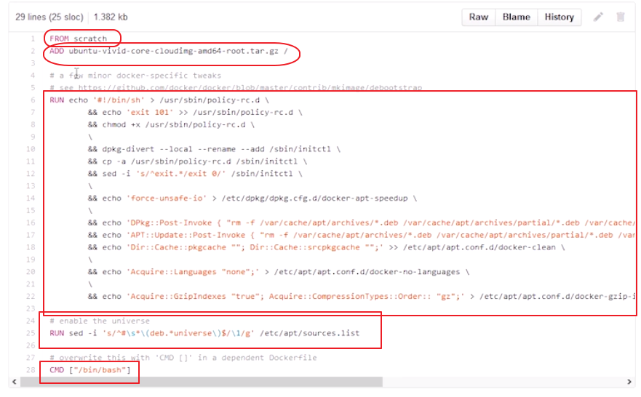

FROM scratch->Baseimage/ One on top of which we build everything else

ADD-> add compressed tar ball. Also, it is placed on root dir of image

ADD ins adds files to our images

RUN-> lot of commands, executed as a single RUN instruction.

REASON: TO minimize number of layers in our image.

Probably 10-12 image layers are created,if we use multiple RUN.

08_06-Wrapup

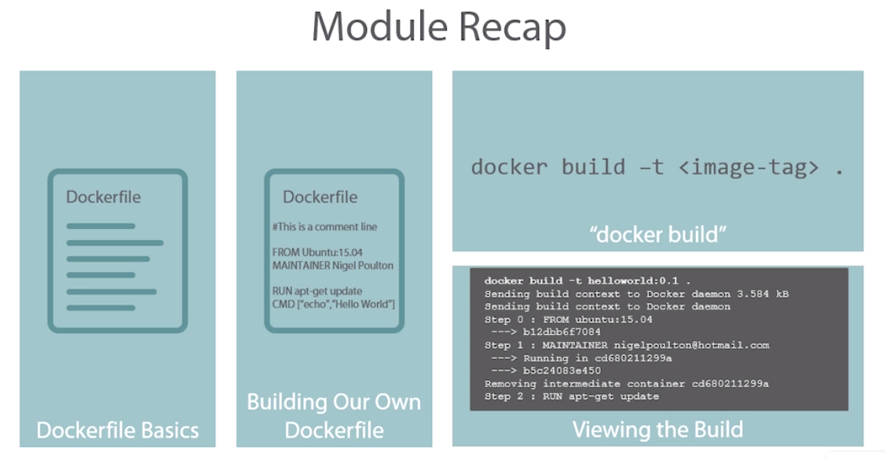

1.)Dockerfile

-plain text, human readable file..Infact human written.

-Starts with Capital ‘D’

2.)Dockerfile

-Instruction value

With one ins. Per line.

- Read from top to bottom left to right

3.) Build docker containers from Dockerfile using docker build cmd.

We can use tag , to know what they are

4.)Docker daemon reads and executes ins. From Dockerfile.

Line by line committing new image layer for each instruction executed

Devops_09. Working with Registries

09_01-Module Intro

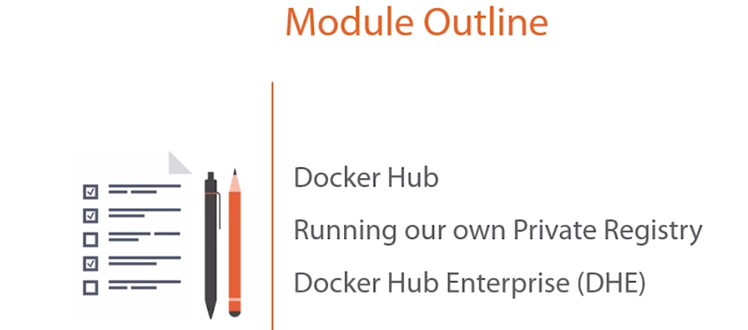

09_02-Creating a Public Repo on Docker Hub

Default public & private registry.

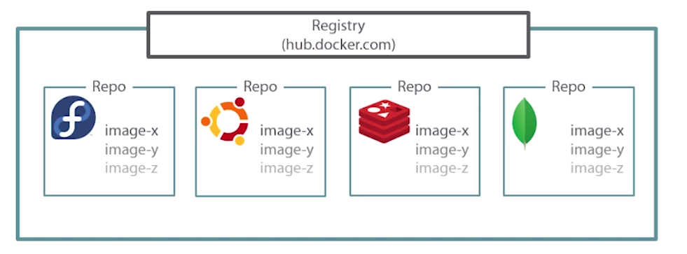

Repos live inside registries.

We are pulling images, it is getting pulled from dockerhub. Every pull command done till now, is pulling image from dockerhub.

Push images images to dockerhub:

In order to push images to dockerhub, we need dockerhub account.

# we can create a/c from CLI from dcoker host using docker login command.

Repos on dockerhub can be private/public.

Public repo: open for anyone & everyone to download images. They can’t modify inside our repository.

Private repo: Not open to public. Suppose we have image that we don’t want to be available to public, then private is better option

We can get 1 free private repository.If needed more than one, we need to get credit card out((NOW WE ARE NOT ABLE TO CREATE 1 PRIVATE REPO ALSO))

09_03-Using Our Public Repo on Docker Hub

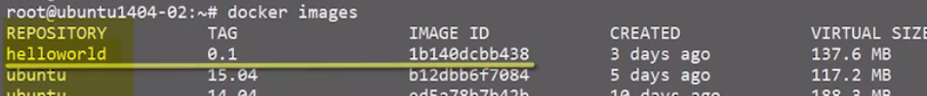

We are going to work with this helloworld image..

1st column is repository, is where image comes from.

